Annual report
April 2023 to March 2024

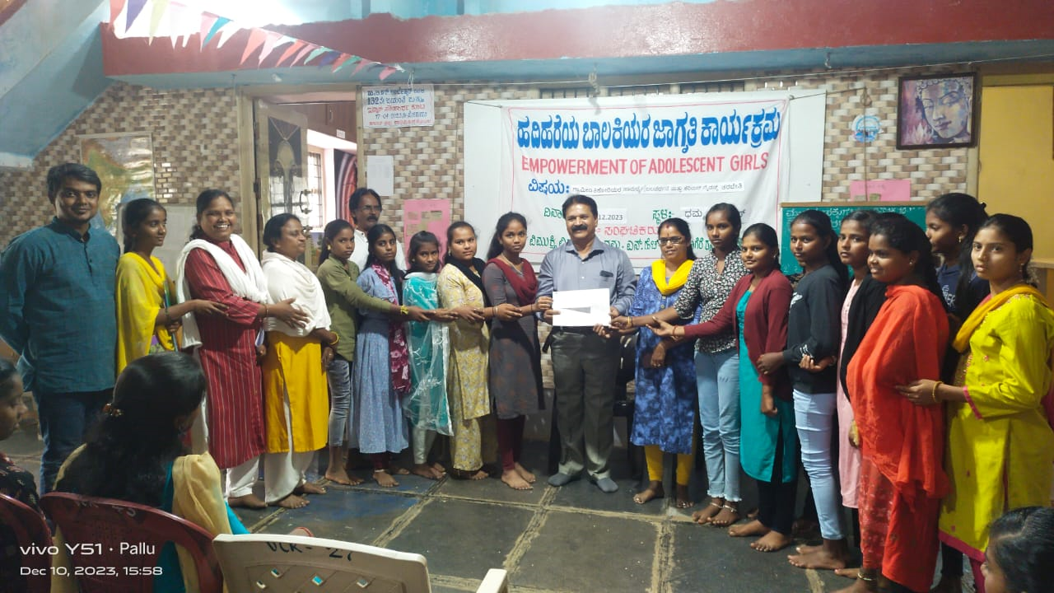

Vimukthi Vidya Samsthe
Dhamma
NH-48, Davangere Road,
MK Hatti Post, Chitradurga-577502
Karnataka, India

Program: Empowerment of Adolescent girls in Chitradurga Block
Supported by Visthar-APPI Bangalore
Implementing Agency: Vimukthi Vidya Samsthe-Chitradurga
Program head | Activity carried out
P1 Capacity building of project staff and volunteers on the proposed project, roles and responsibilities and norms  ¹§âA¢ ªÀÄvÀÄÛ ¸ÀéAiÀÄA ¸ÉÃªÀPÀjUÉ APPI project PÀÄjvÀÄ MjAiÀÄAmÉÃ±À£ï-20 d£ÀjUÉ | On 1.8.2023 an orientation session was held at Dhamma for APPI team, Vimukthi staff and Volunteers (20 persons) .Mr. Vishwa Sagar the consultant and Mrs. Annapoorna (program coordinator) presented to the participants on vision, mission, objectives, activities, strategies, target villages, target population, sanctioned budget, number of staff recruited pertaining to empowerment of adolescent girls .  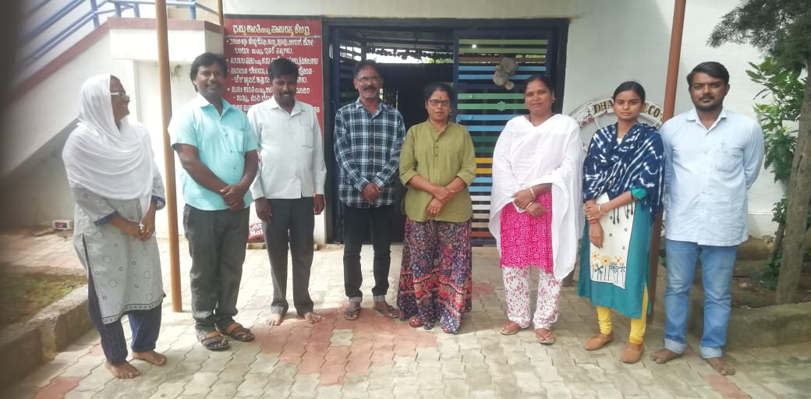  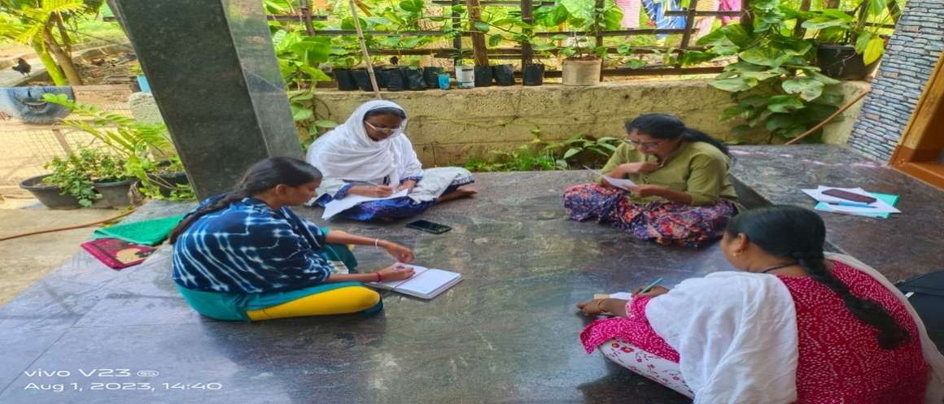
P2- Workshop on creation of training/resource materials on personal hygiene, career guidance, gender and other related for adolecent girls  ºÀ¢ºÀgÉAiÀÄzÀªÀjUÉ ªÉÊAiÀÄQÛPÀ ¸ÀéZÀÑvÉ, PÉjAiÀÄgï UÉÊqÀ£ïì, °AUÀvÀé EvÀgÉ vÀgÀ¨ÉÃw PÉÆqÀ®Ä PÉÊ¦r vÀAiÀiÁjPÉUÉ ¥ÀjtÂvÀgÀ PÁAiÀÄðUÁgÀ-15 jAzÀ 20 d£À ¥ÀjtÂvÀgÀÄ ªÀÄvÀÄÛ ¹§âA¢. | On 12.08.2023 a workshop to prepare a training manual on personal hygiene, career guidance, gender sensitization, and environmental issues was held at Dhamma. It was inaugurated by Dr. Girish the Taluk health officer, attended by APPI-Visthar program staff, Vimukthi team, Anganavadi and Asha supervisors, NGOs, social experts, child rights activists, adolescent girl students, representatives from District Child Protection Unit and others attended it. Mrs. Annapoorna, Mr. Sarovar, Dr. Reshma, Mrs. Nagarathna, Mrs. Bibijan and Vishwa sagar facilitated the sessions through PPT, and video presentations and aimed the participants to understand the idea of bringing up a training manual to be apply in schools, hostels and community to educate and empower the adolescent girls .A group discussion was also held to identify the main stuffing for the manual and a committee is set up to collect background/required materials . The committee is seriously working on the training manual and it is expected to be ready by 15th of September, which will be shared with Visthar.  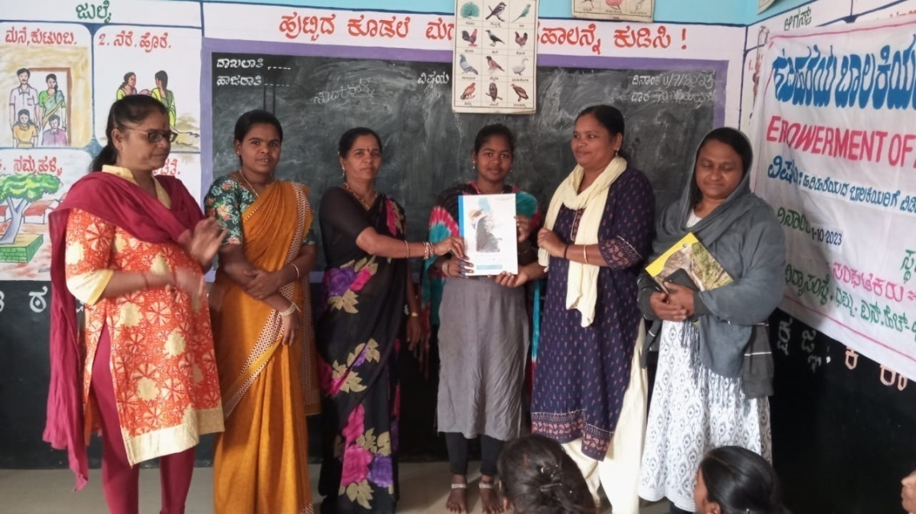  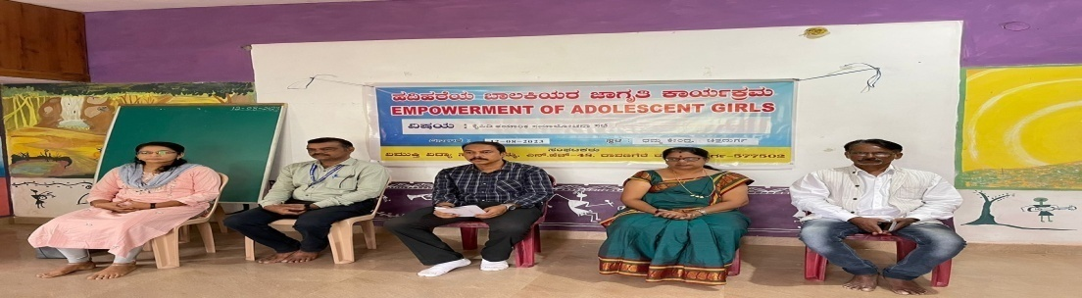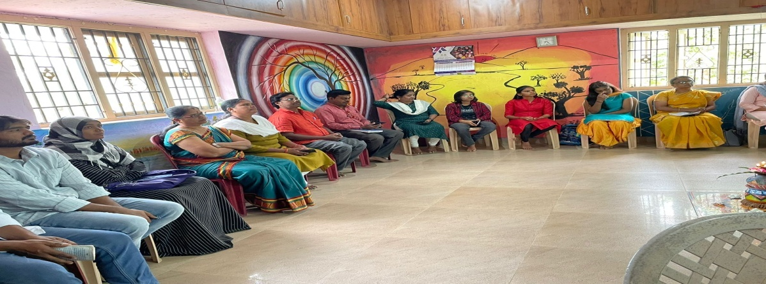  Dr. Girish sharing the points on personal hygience and Annapoorna sharing on gender sensitization
P3 Editing and printing of training materials  PÉÊ¦r wzÀÄÝ¥Àr ºÁUÀÆ ¦æAnAUï | Vimukthi has printed a 35 page training manual and got it 50 set of it and has distributed 2 set to each adolescent girls club for their further reading/reference and based on theier studies test/competitions were held in the form of essay writing, debate, drawing at community and hostel level and at Dhamma. All these documents have been maintained at office. Majority of the participant girls have writeen and drawn meaningfully and we believe that girls have followed well the training manual and it is quite handy and useful. We plan to print another set of 50 copies in 2nd half of the year .
P4 Formation of adolescent girl’s club, weekly meetings  ºÀ¢ºÀgÉAiÀÄzÀ ¨Á®QAiÀÄgÀ PÀè¨ï gÀZÀ£É ªÀiÁr (20-30 d£À) ªÁgÀPÉÆªÉÄä ¸À¨sÉ ªÀiÁqÀÄªÀÅzÀÄ | 3 Community organizers and the Program Coordinator have visited regularly to all 20 selected villages and 5 hostels and following process has happened:  - Identification and formation of adolescent girls club is done in 20 villages and 5 hostels listing of 750 Adolescent. List is computerized.  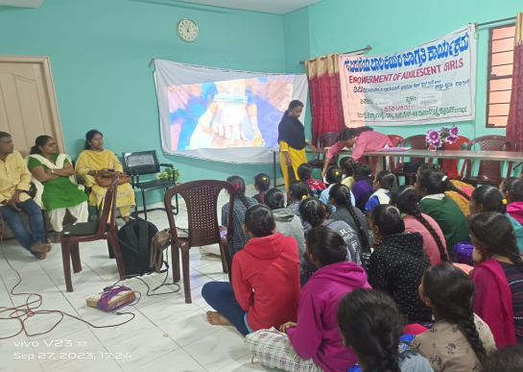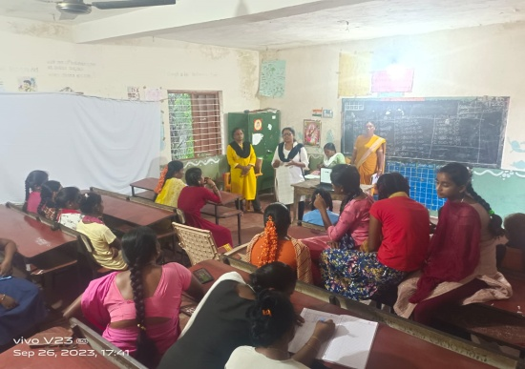  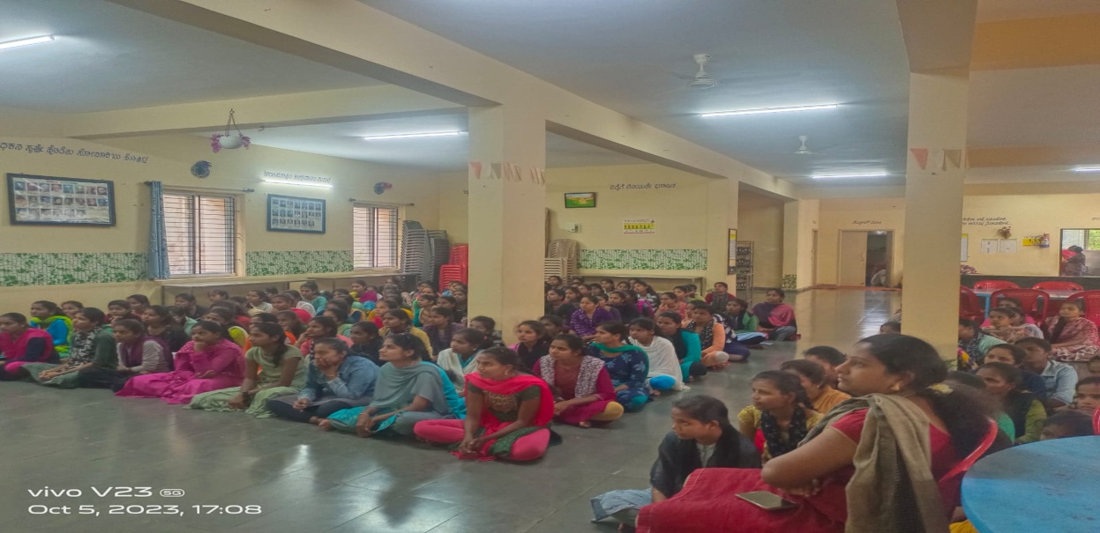  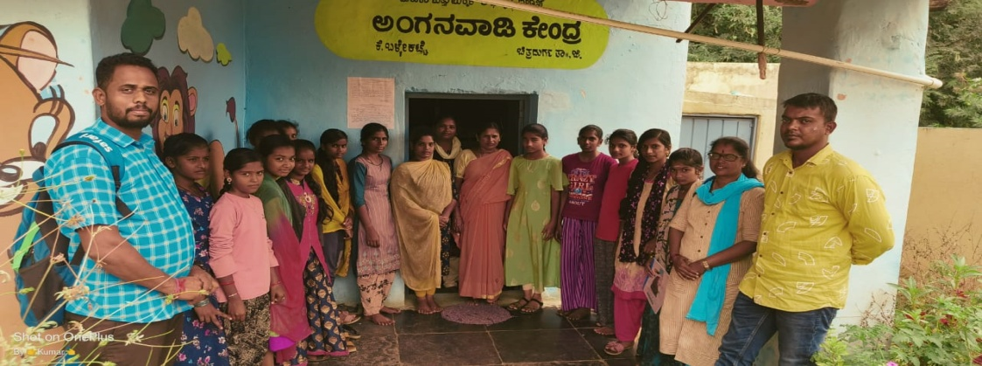  - Essay writing, debate and drawing Competitions were held in6 schools and in one slum area on Environment, constitutional values ,78 Girls and boys , who were winners were given certificates and medals as a token of appreciation and entry to schools. Participants list and papers of competitions are maintained  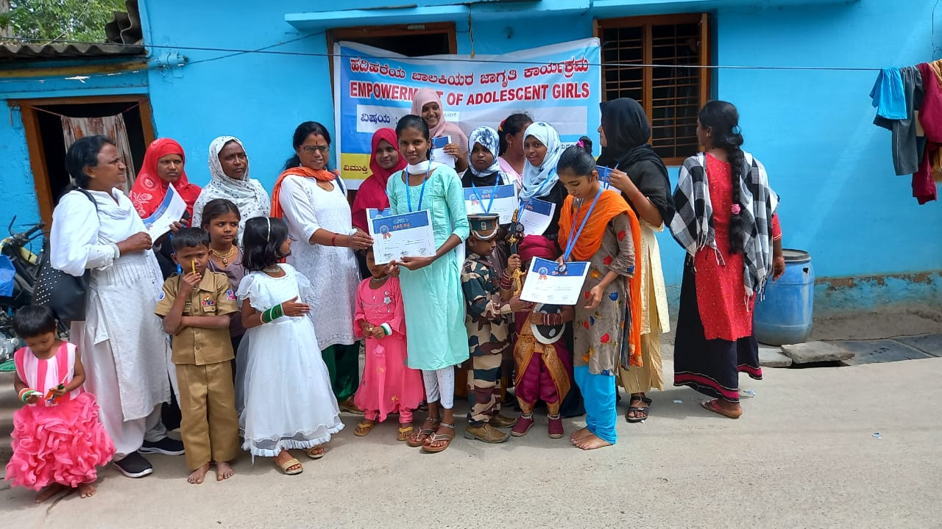  Adolescent girls were honored at Maruthinagara Muslim area-attended by Bibijan and Annapoorna  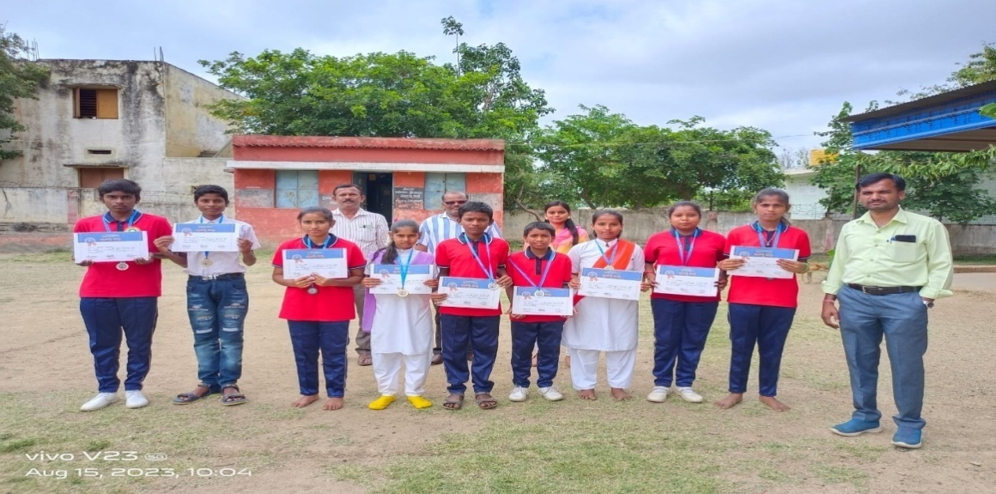  Students were honored at Belagatta High school, attended by Arpith the student Volunteer  - 25 Anganavadi and 25 Asha workers have been met in the working area, personal meetings have been held and contact is established with them sharing on the APPI-Visthar program .List is computerized.  - Permissions have been obtained from education department, Taluk health department and from Women and child department to work in project area. Permission letter is filed and given to all project staff
P5 Orientation on Personal hygiene at hostels and community level for girls  ºÀ½î ªÀÄvÀÄÛ ºÁ¸ÀÖ¯ï ªÀÄlÖzÀ°è ¨Á®QAiÀÄjUÉ CªÀgÀ ªÉÊAiÀÄQÛPÀ ¸ÀÄavÀé ªÀÄvÀÄÛ DgÉÆÃUÀå «ZÁgÀ PÀÄjvÀÄ ªÀiÁ»w ¤ÃqÀÄªÀÅzÀÄ  ¸É¥ÀÖA§gï ¤AzÀ -25 PÀè¨ï ¨Á®QAiÀÄjUÉ | From first week of August 2023 to end of December orientation sessions have been held in 20 villages and 5 hostels. A minimum of 25 girls at community level/school and maximum of 200 girls at residential schools and hostels have attended the sessions on personal hygiene, conducted by Annapoorna the coordinator, Community organizers like Nagaratna, Bibijan, Kumar.T, Aranya and Arpith. In about 10 villages we have involved Anganavadi worker Asha and ANMs as trainer in orienting girls. About 850 girls have benefitted from the orientation.  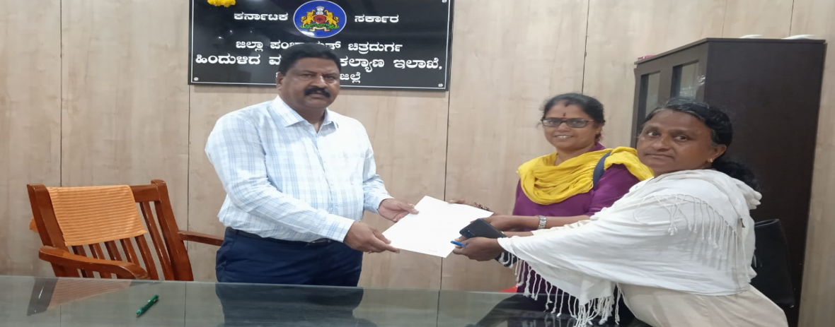  Submitting letter to BCM hosterl Deputy Director for permoission to work in BCM ladies hostels in Chitradurga. A permission letter is obtained in this regard  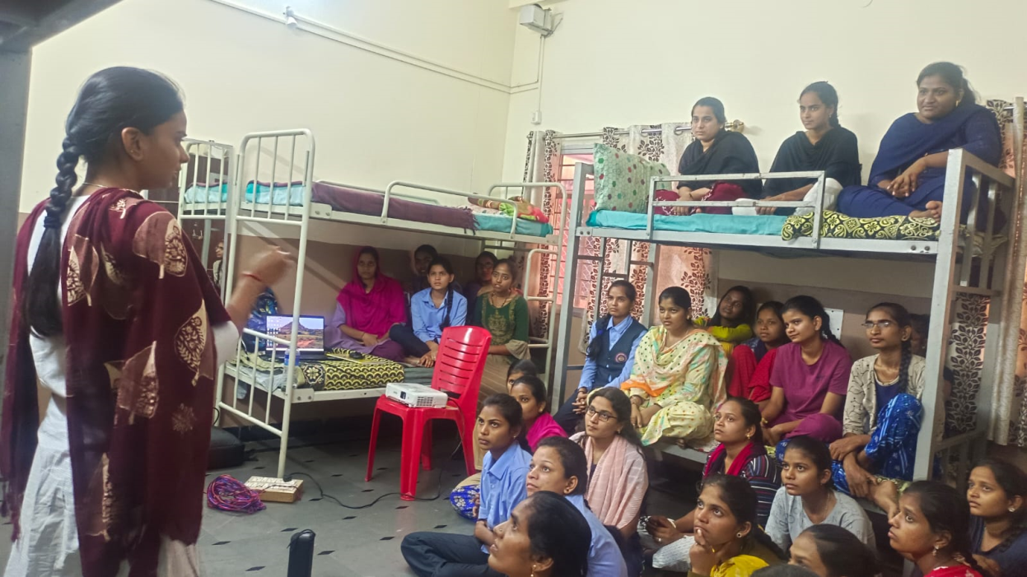  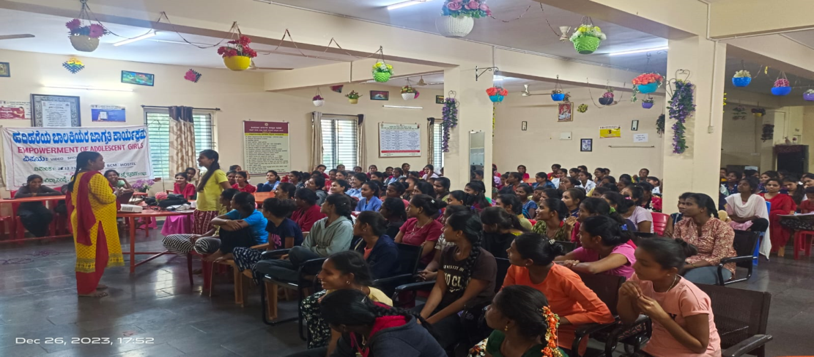
D±Á, CAUÀ£ÀªÁr, ¸ÀéAiÀÄA ¸ÉÃªÀPÀgÀÄ ªÀÄvÀÄÛ ºÁ¸ÀÖ¯ï ªÁqÀð£ï gÀªÀjUÉ D¦ AiÉÆÃd£É §UÉÎ vÀgÀ¨ÉÃw ¤ÃqÀÄªÀÅzÀÄ  28.8.23 | On 24.8.2023 , one day training was held at Dhamma for 12 Anganavadi workers, 10 Asha health workers, 2 school teachers and 3 student volunteers from the selected 25 villages. It was inaugurated by Mrs. Reshmabanu the Vice President of MK Hatti Grama Panchayat. .Mr. Vishwa Sagar the consultant and Mrs. Annapoorna (program coordinator) Mr. Sarovar the resource person and rest of APPI team presented to the participants on vision, mission, objectives, activities, strategies, target villages, target population, pertaining to empowerment of adolescent girls through PPT, Video and direct talk and allowed the participants for the discussion, sharing on the issues of adolescent girls, kind of work being carried out by Asha, Anganavadi workers for Adolescent girls, challenged faced by them and ways to work together, especially they playing the volunteer role in the project. All the participants appreciated Vimukthi for such an unique program designed for adolescent girls in the area and happily agreed to align with Vimukthi for the success of the program. Suggestions were also taken for designing the training manual. Creative group games, group discussions, Dhamma campus walk were also introduced as a strategy to inspire the participants to actively take part in the sessions. –A list of participants and photo is attached  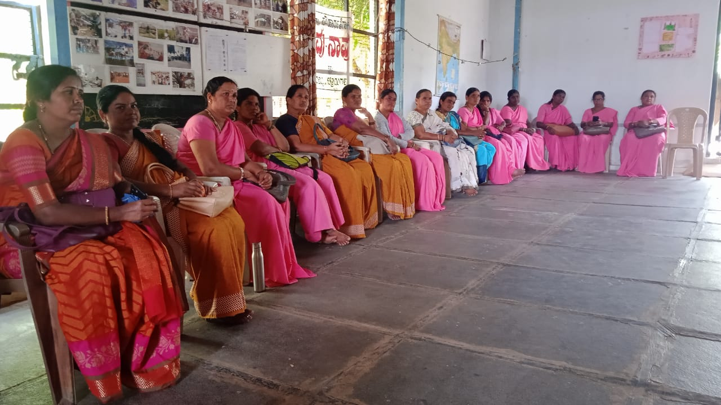  Anganavadi , Asha, Student Volunteers in a Training on Adolescent girls project, at Dhamma  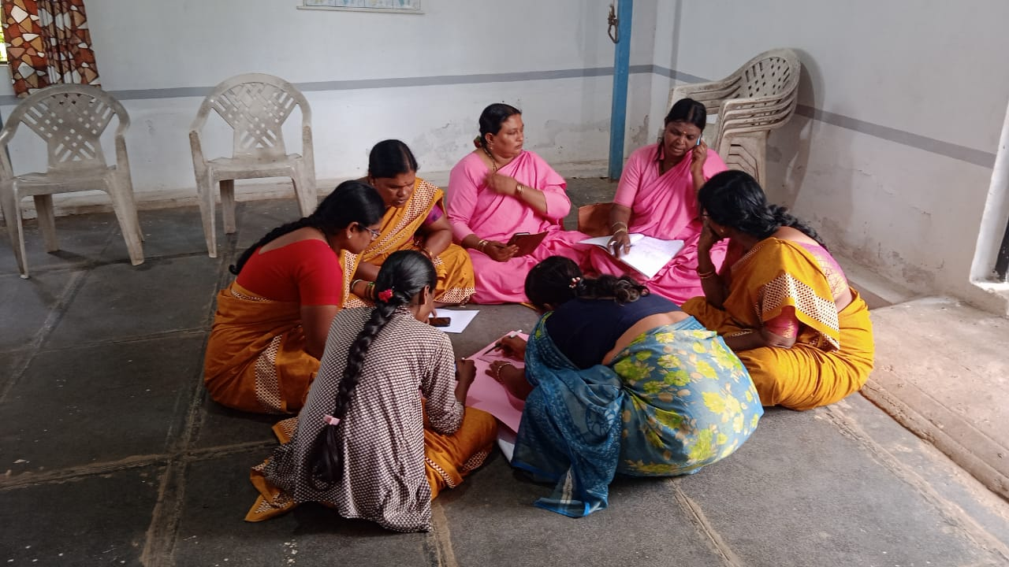  One group of Asha and Anganavadi teachers engaged in group discussion
¨Á®QAiÀÄjUÉ CªÀgÀ DgÉÆÃUÀå, PÉjAiÀÄgï UÉÊqÀ£ïì, £ÁAiÀÄPÀvÀé, °AUÀvÀé , ¥Àj¸ÀgÀ eÁUÀÈw PÀÄjvÀÄ 2 ¢£ÀUÀ¼À vÀgÀ¨ÉÃw ¤ÃqÀÄªÀÅzÀÄ. 10 ¨Á®QAiÀÄgÀÄ , 25 ºÀ½îUÀ¼ÀÄ.  CPÉÆÖ§gï -23 | A two days training for adolescent girls was conducted on 28th and 29th , October 2023, for 50 girls Number of participants (please refer Annexure- for the list) for 25th and 26th of November for 60 gilrs and 9th and 10th December 2023 for 25 girls at Dhamma.  Resource person and a brief report of the training with photos
  No | Name of the village | High school | PUC | participants
  1 | Vijapura | 11 |  | 10
  2 | Vijapura Gollarahatti | 6 | 4 | 10
  3 | Lakshmisagara | 09 |  | 10
  4 | Inalli Kurubarahatti | 10 |  | 10
  5 | K.Ballekatte | 10 |  | 10
  6 | Dhamma Alemari colony | 02 |  | 02
   |  | 52 |  | 52
  No | Name | topic | Method/subject covered
  1 | Kumar and Sarovar | Introduction, Dhamma campus walk  Inauguration | Introduction of participants through games and fun  Understanding our eco system and eco sanctuary through Dhamma campus walk.  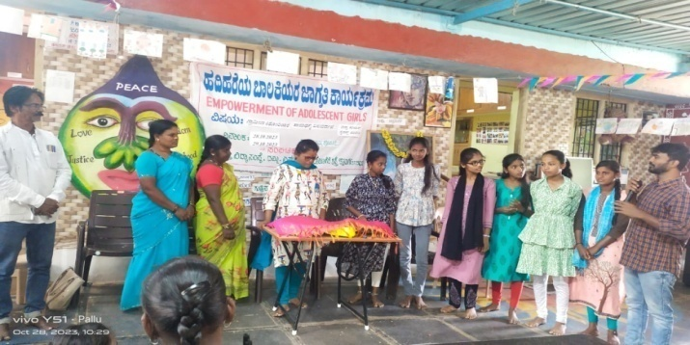  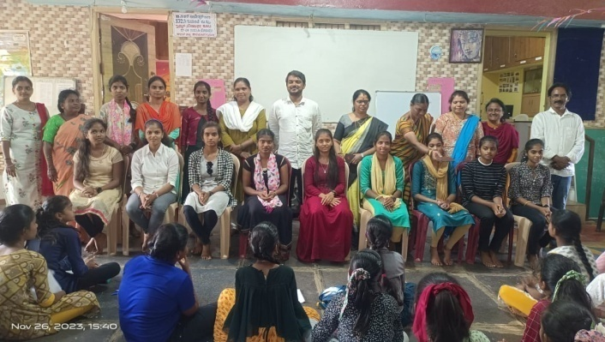
  2 | Mr. Sarovar and Bibijan | Career Guidance | Personal experience sharing, PPT, question and answer  Understanding Career  Opportunities after 10th and 12th pass/fail  How to build career  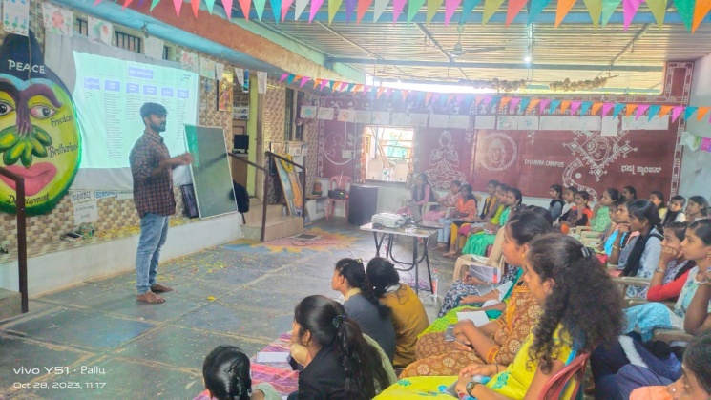  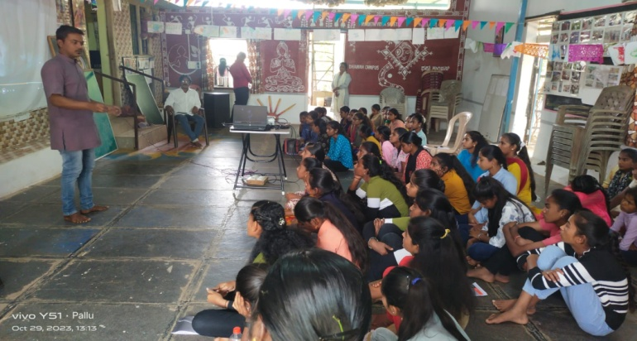  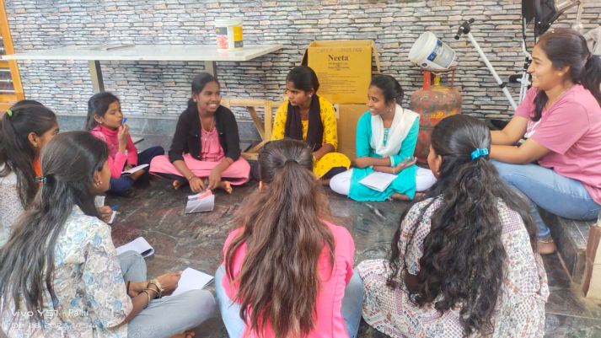
  3 | Mrs. Annapoorna and Vishwa Sagar.R | Gender sensitization | Used creative exercises, PPT, personal sharing as method of teaching  Understanding difference between sex and Gender  Biological and societal difference  Gender discrimination at home, schools, religious institution, and politics.  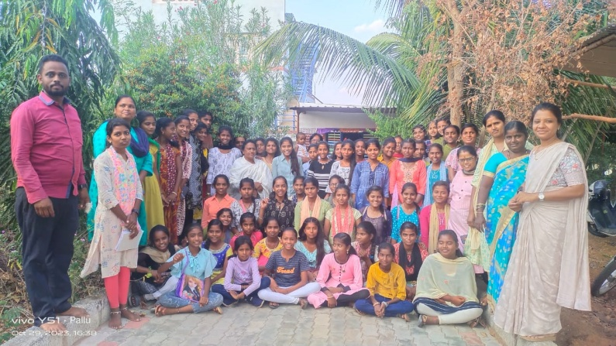
  4 | Dr. Sunitha and Mrs. Nagarathna | Personal Hygiene | Personal experience sharing, PPT/video show, question and answer.  Dr. Sunitha explained the participants on importance of cleaning body parts, issues that they face during menarchy and monthly periods, use of sanitary napkins, types of food intake, particularly taking vitamin C and other issues.  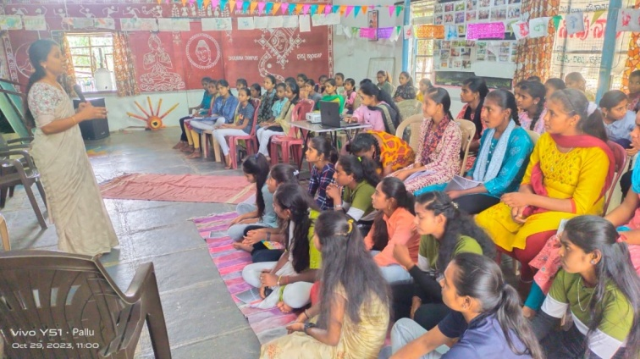
  5 | Eco-system  Aranya | Team | Participants were divided in to 5 groups with a facilitator asked them to prepare skit, and songs on issues, problems, challenges of our eco system and our role in protecting and promoting good eco system.  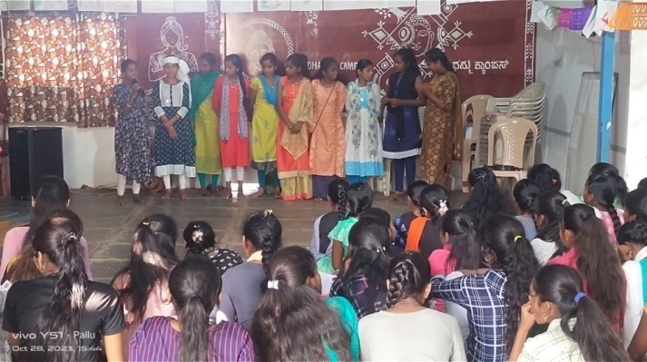
  6 | Sports  Quiz  Memory test | Team | Balloons bursting game, dance to the music and number game, pulling rope, running race competitions were held.  32 different items were displayed relating to Gender, personal hygiene, career guidance, eco-system for memory test.  Quiz was also conducted relating to the subjects covered in the 2 days training  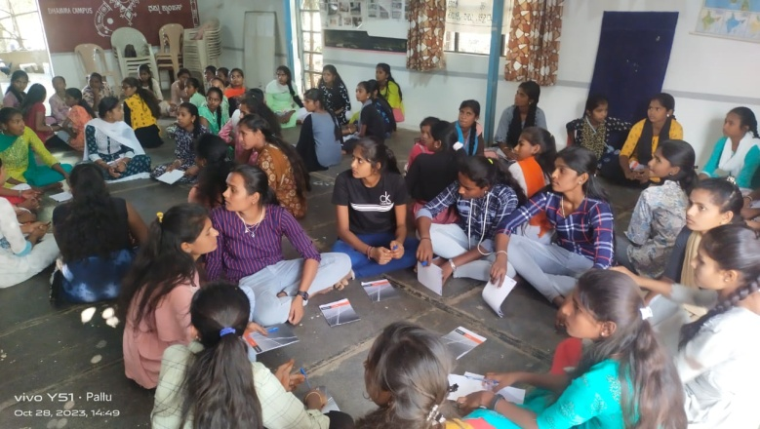  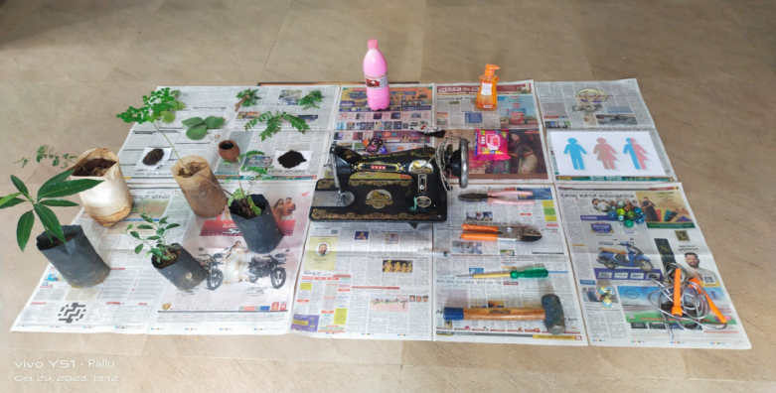  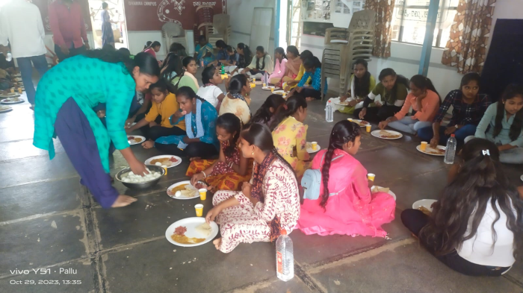  Tasty and protein food was supplied on both days
Environmental education and plantation in schools

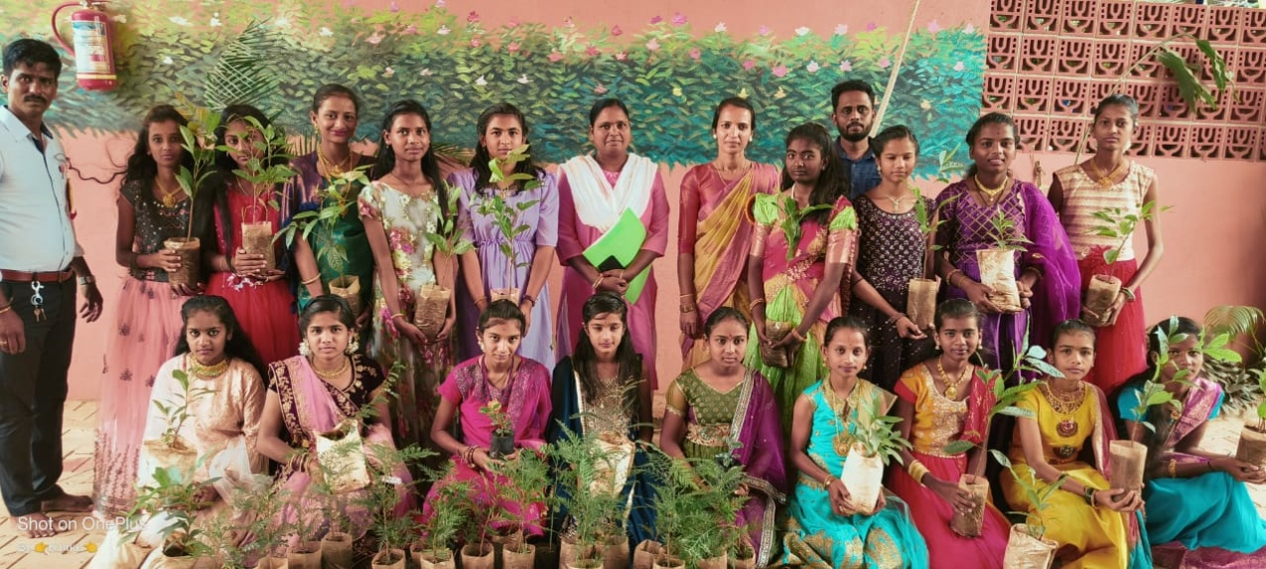

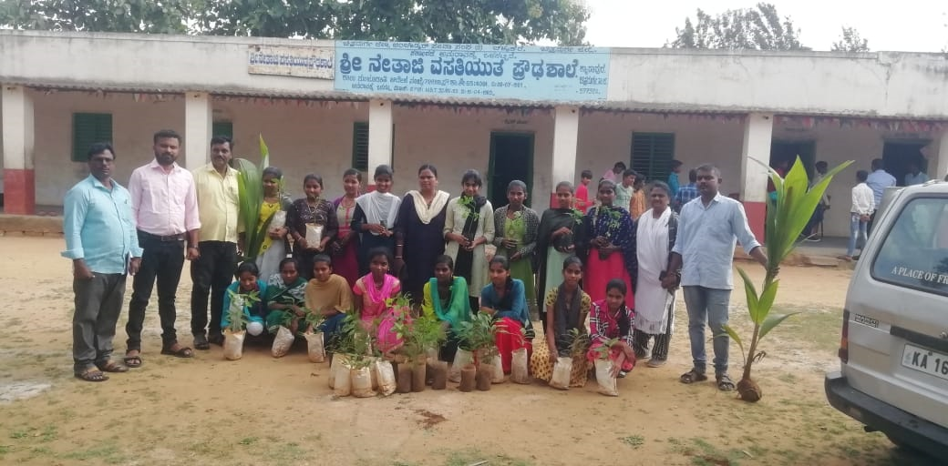

P8 Educational and medical support to selected disabled and economically backward girls  §qÀ ªÀÄvÀÄÛ «±ÉÃµÀZÉÃvÀ£À ¨Á®QAiÀÄjUÉ DgÉÆÃUÀå ªÀÄvÀÄÛ ±ÉÊPÀëtÂPÀ £ÉgÀªÀÅ (vÀ¯Á MAzÀÄ ºÀ½îAiÀÄ M§âgÀAvÉ 25 ¨Á®QAiÀÄjUÉ)  CPÉÆÖ§gï-23 | The needy girls were selected by the members of girls club and Volunteers at villages and hostel level with the support of project staff in first week of December 2023 based on their social, economic and educational status. A list of 25 such girls from 20 villages and 5 hostels were made and they were invited for an orientation cum cheque distribution program held on 9th and 10th of December 2023. Due to some technical problems (either expire of bank account or other reasons) A cheque for 19 girls x Rs.1000, a total of Rs.19000 was issued and the amount is being credited to their personal bank account
P9 Medical camp for specially challenged girls  «±ÉÃµÀZÉÃvÀ£À ªÀÄPÀÌ½UÉ DgÉÆÃUÀå ²©ügÀ. | Prior to the camp, in first week of November a survey of girls with disabilities was made by the field staff in support of village level Volunteers. The health department heads were contacted and invited to conduct the camp with free medicines. As a result on 9.11.23 a medical camp was conducted at Dhamma and it was attended by 18 Girls and 2 boys with disabilities along with their parents . The check-up and free medicines were distributed by 2 doctors (Dr. Vani, Dr, Sachin) from Primary health Centre, Kysapura, Dr. Reshma Ali from AYUSH, Mrs. Pushpa the Physio therapist, Mrs. Apoorva Sreedhar the Psychiatrist, Mr. Hariprasad the Nodal officer. Dr. Girish Tho, Mr. Manjunath the District health education officr and Mrs. Janki and others facilitated. Dumb and duf, MR, Loco motor, visually challenged, hearing-impaired cases were diagnosed and given medicines. 5 Chilren with major problems were referred for further investigation and treatment.  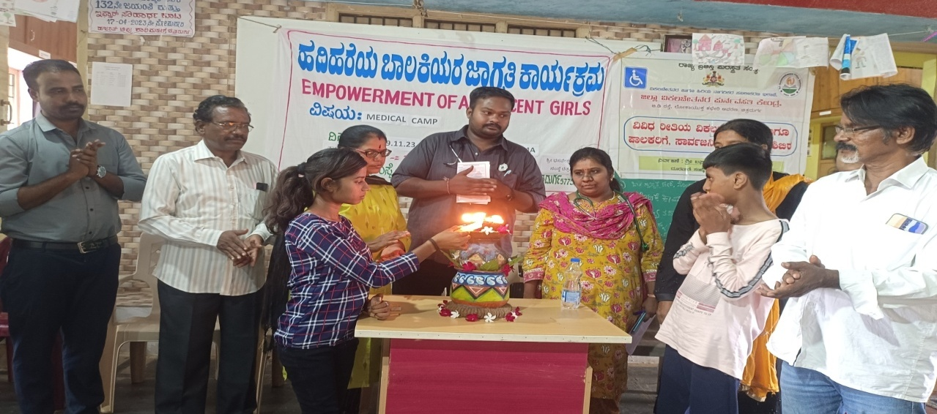  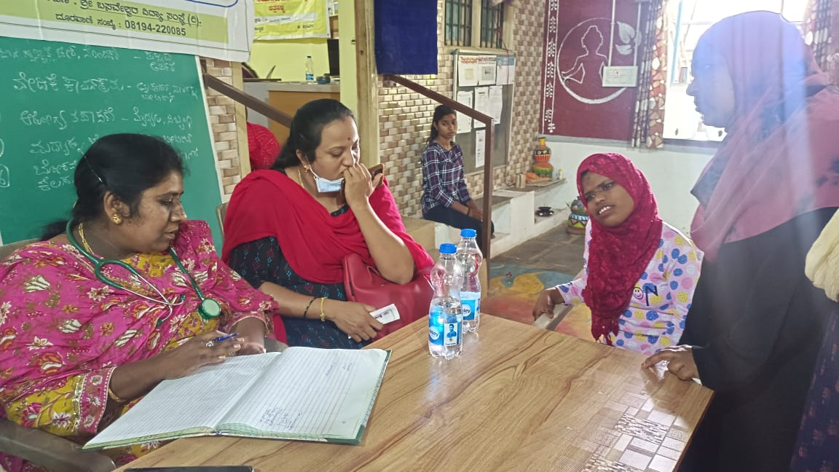  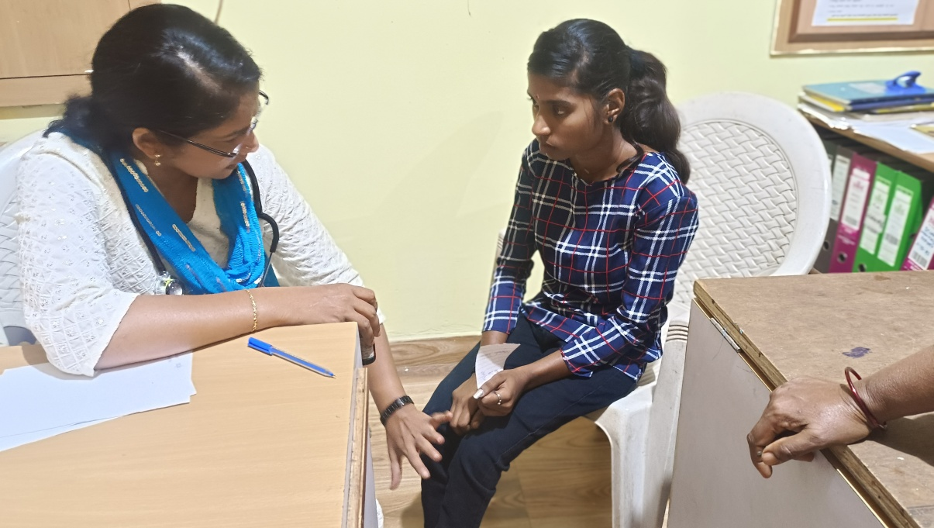
P10 Setting up a resource centre for girls in a centrally located village  ¸ÀA¥À£ÀÆä® PÉÃAzÀæ | Prior to the establishment of the centre a survey was undertaken by the field staff to identify the appropriate place for the purpose. A survey was made in Inalli Kurubarahatti, Kysapura, Lakshmisagar, Gulayanahatti, MR nagara, Mallanakatte and few places in Chitradurga city. After a series of consultation with school authorities and the volunteers it was decided to set-up at MR nagara village of MK Hatti GP, which is adjuscent to the city.  A list of participant girls was prepared by the filed staff Nagaratna, Bibijan and Aranya and finally it was decided to open the centre. On 03.01.2024 the inauguration of the centre was done by the BEO Mr. Nagabhusan along with the School teachers and HM, Asha and Anganavadi teachers, parents and Vimukthi team.  The centre is put up in room given by the GHP school, MR Nagara and 2 computers (one new and one new) color printer with web camera, 2 tailoring machines, 2 chairs, 3 tables, 3 stools. A mini library containing materials on child rights, personal hygience, Child labor, Gender, environment, career guidance etc been kept for the use of girls.  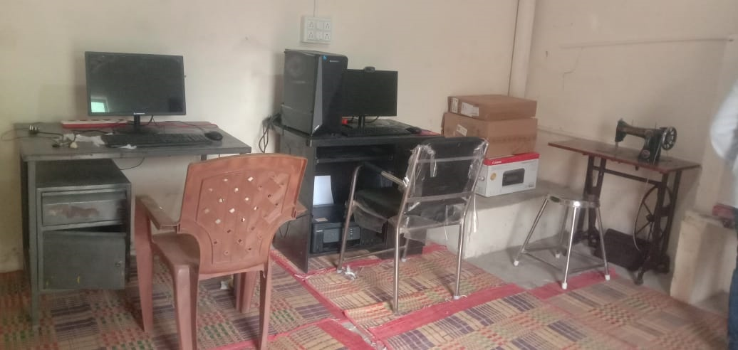  Inaugural function. 15 girls are attending for Computer sessions and 5 girls for Tailoring classes.  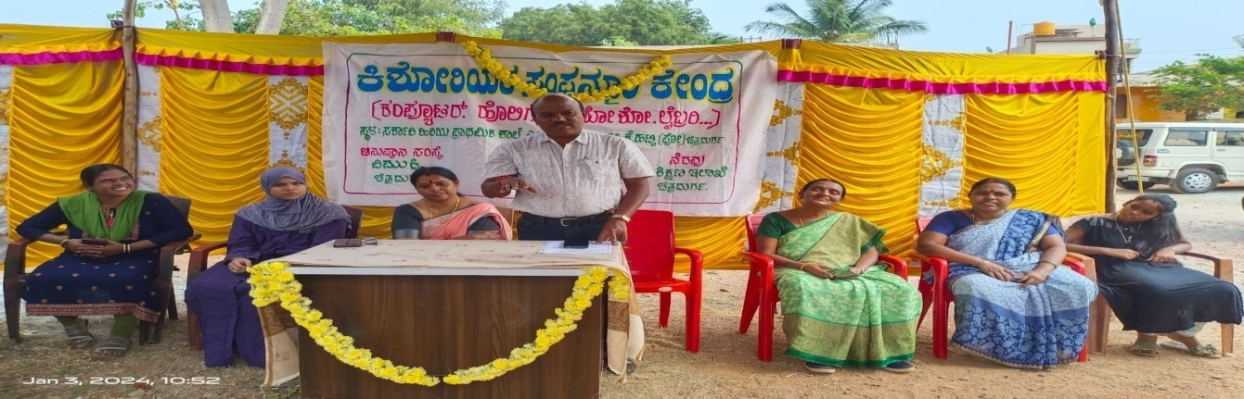  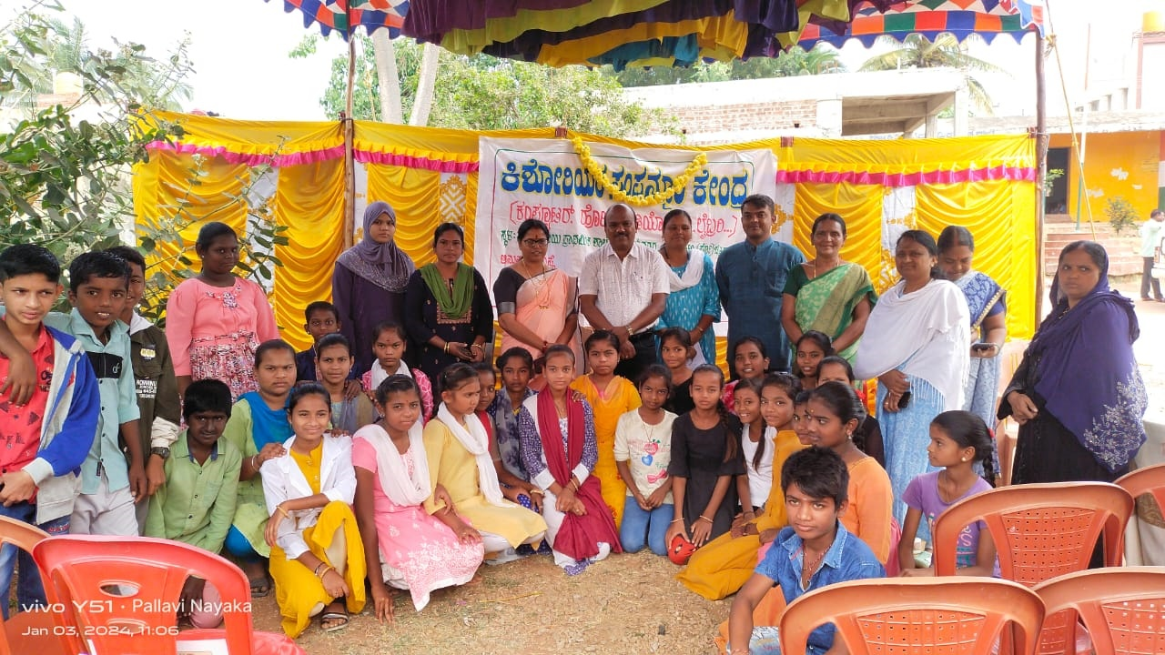
P11 Theatre camps for selected 20 adolescent girls for 8 days at Dhamma (music, drama, dance, mask making, martial art, etc)  xÉAiÉÄÃlgï PÁåA¥ï | A 8 days theatre camp was conducted for 24 selected girls from 5 villages from 9.10.2023 to 16.10.2023 with the active support and cooperation of Asha and Anganavadi workers From each village following number of adolescent girls had participated. Prior to the camp series of meetings were held in villages  Participants  Resource persons
  No | Name of the village | Number of participants
  1 | Neelayanahatti | 6
  2 | Kysapura | 3
  3 | Gulayanahatti | 4
  4 | MR Nagara | 6
  5 | Sadarahalli | 3
  6 | Dhamma alemari colony | 2
   |  | 22
  No | Name | Topics
   | Introduction  Dhamma campus walk  Inauguration | On their arrival girls had warm welcome to Dhamma and through a creative game introduction of the participants, resource persons was done. Later they were taken for Dhamma campus walk, where they were oriented on agro forestry, horticulture, birds and animal world of Dhamma and explained about Dhamma eco-sanctuary  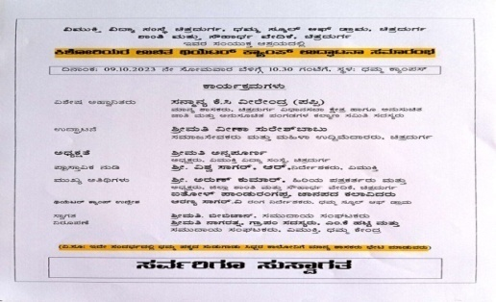  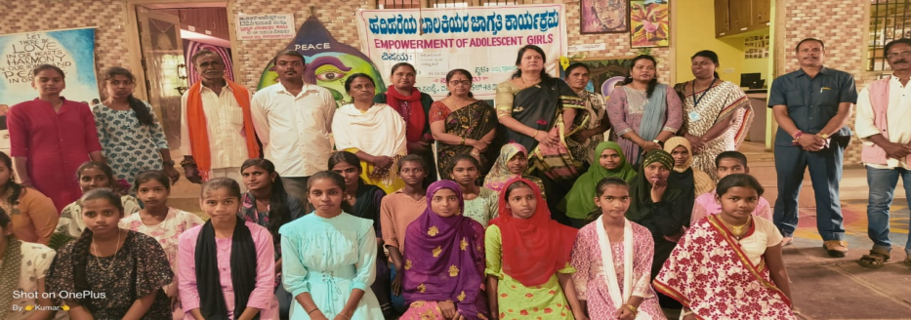  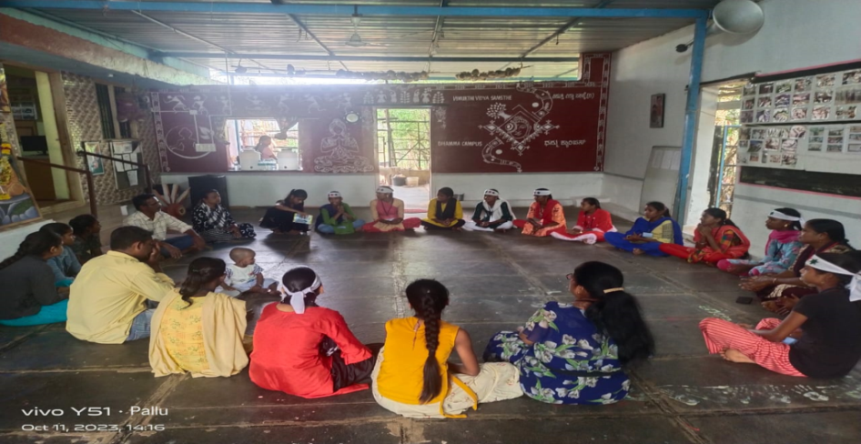
  1 | Pandurangappa  Aranya Sagar  Kumar T | Folk songs, Folk dance  , Kolata  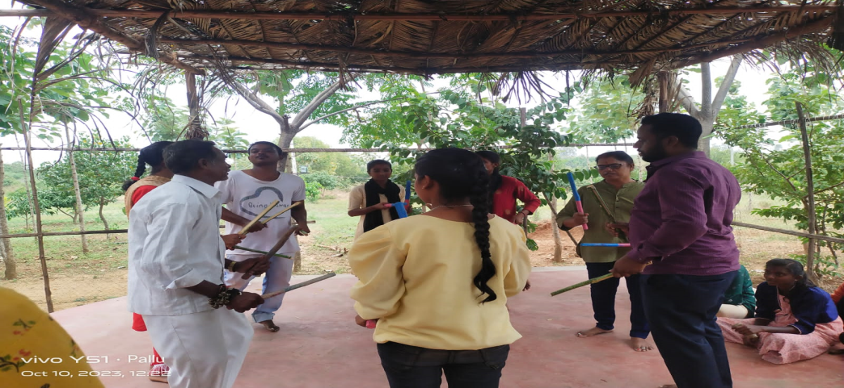
  2 | Arpitha  Annapoorna  Nagarathna | Folk and patriotic songs and dance  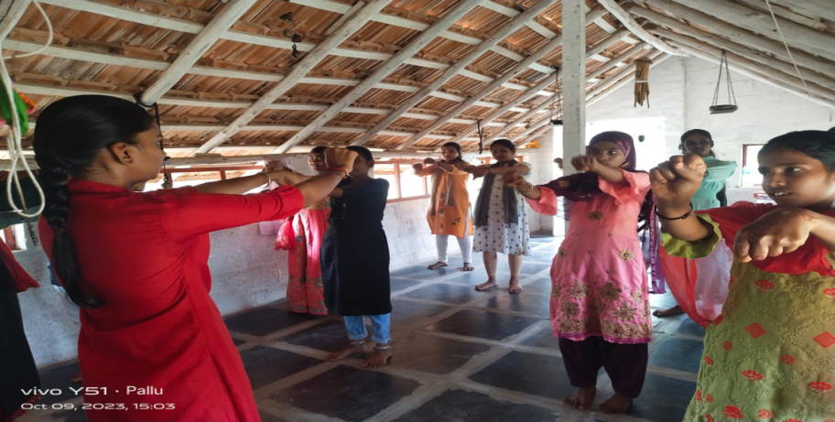
  3 | Kumar H  Aranya | Banner making  Creative drawings and painting was done for a all the participants by Kumar.H the artist and Mr. Aranya sagar, the theatre person.  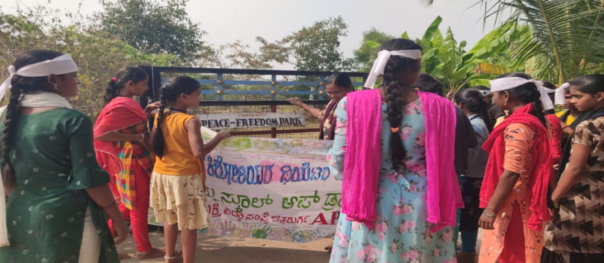  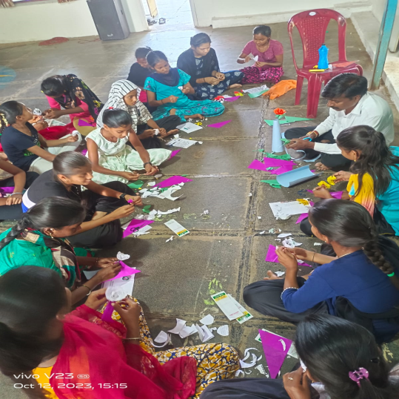
  4 | Sarovar  Annapoorna  Bibijan | Simple Yoga and meditation sessions were conducted for half day by the resource person Sarovar and facilitator Annapoorna and Bibijan. Girls liked the session and actively participated. Mrs. Annapoorna also explained the benefit of yoga and meditation.  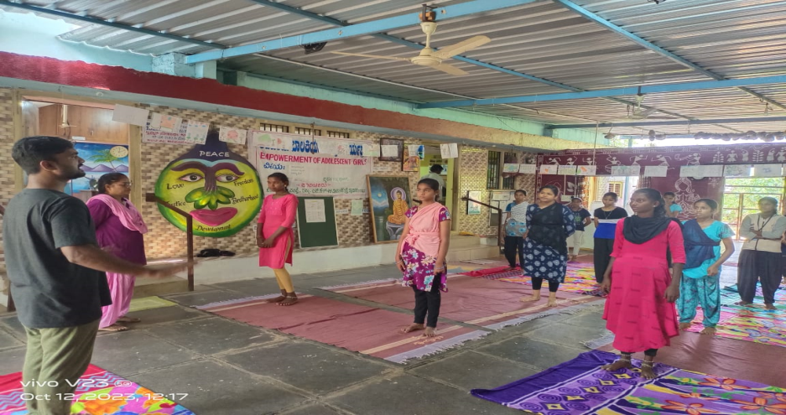
   | Picnic | A half day picnic was carried out to Yogavana betta (A medicinal plant forest) and to Nijalingappa memorial (museum)  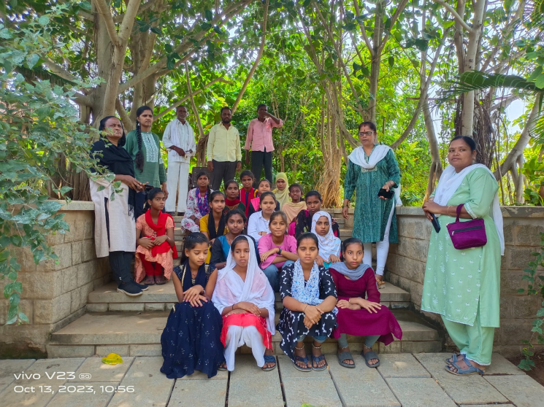  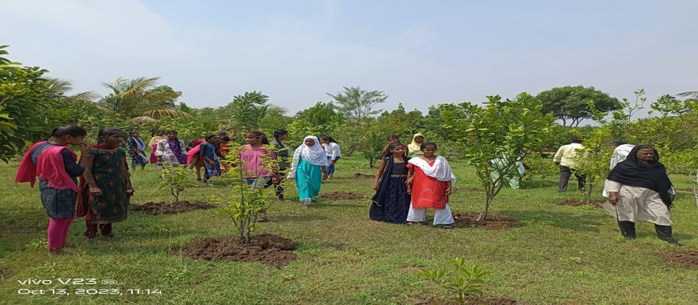
  4 | MLA office | On the final day , on the invitation of Local MLA office, all the participants and the team went to MLA office and their they presented Dance, Kolata, folk songs and other activities that they had learnt. There were about 40-50 people, including the officers of MLA office and general public witnessed the performance and appreciated very much. Finally Girls were given certificates, medals and gift.  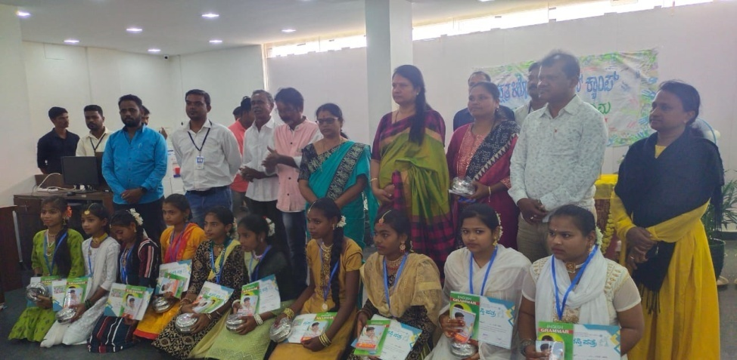
P12 Sports and cultural events and competations like essay writing , debate, drawing on personal hygience, career building at taluk level. | Sports activities have been held at Dhamma for all selected 135 girls from 20 villages and 5 hostels during the 2 days training held in October and November 2023. The competitions like Debate, essay writings, drawing, memory test, quiz, running race, rope pulling, treasure hunting, musical chair, balloon bursting and others were held. A list of winners (first, second, third and consolation) is made. All these girls will be given certificates, medals and memento on 24.01.2024 during international/national girl child day.  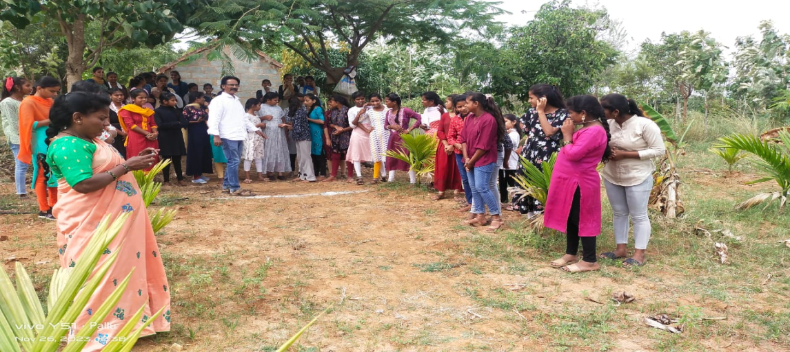  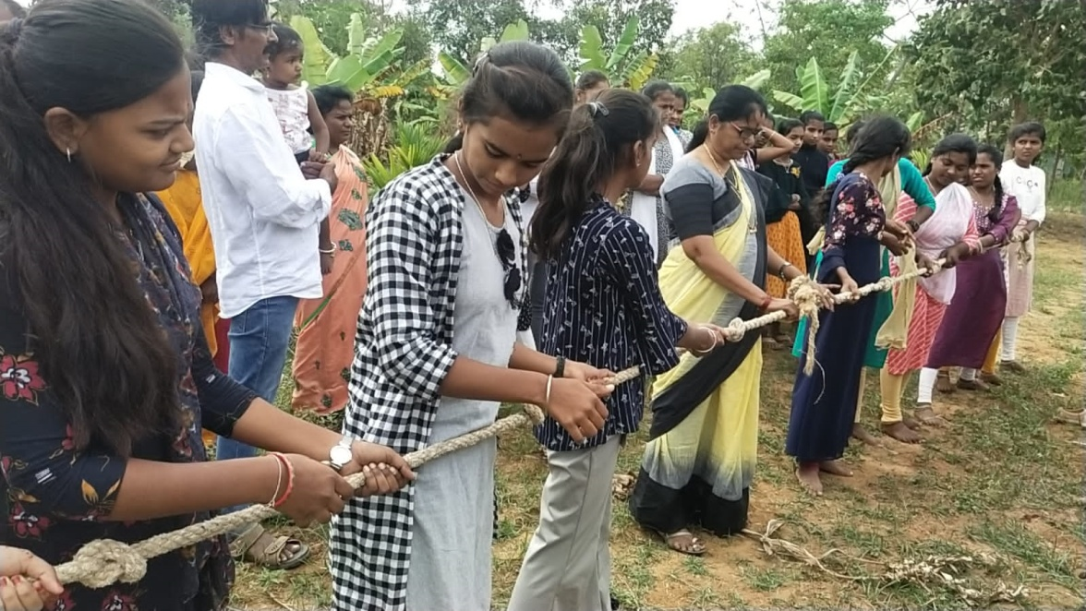
A-5 Office equipments: 1 computer, 4 tables, 4 chairs, 1 racker, | A rented office premises in set up within the Dhamma campus, separately for APPI-Vishthar program. For the effective functioning of the project 3 Community organizers , one Program Coordinator, 1 computer operator, one Consultant have been recruited through interview by the appointment committee of Vimukthi.  Equipments like 2 foldable tables, one computer table, 2 normal chairs, 1 rolling chair, one shelf with locker, one computer system ( CPU, monitor, key board and mouse) have been procured through raising quotations, GST invoice(bills) by paying bank cheque.  Photo and video of the office with equipment and team is attached.  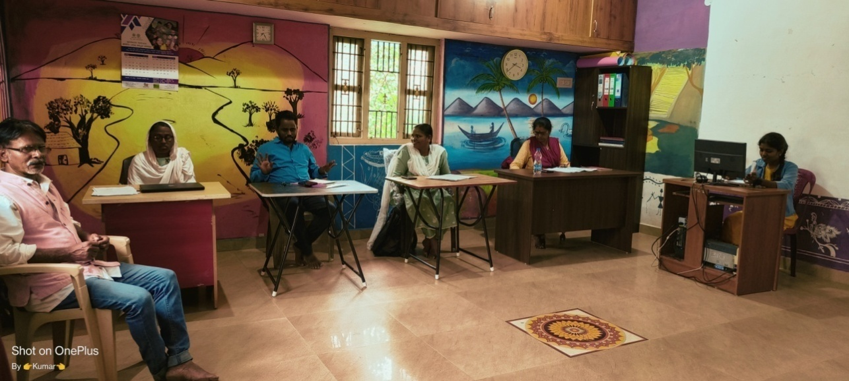  Mrs. Annapoorna-Program Coordinator  Mrs. Nagarathna-Community Organiser-1  Mrs. Bibijan-Community Organiser-2  Mr. Kumar.T-Community organize-3  Ms. Pallavi-System Operator cum Accountant  Mr. Vishwa Sagar.R-Consultant
 | ¤ªÀÄä ¸ÀºÀPÁgÀ ªÀÄvÀÄÛ CxÀð¥ÀÆtð ¨ÉA§®PÉÌ 

Program-World Alergy week 2023 Awareness program
Supported by CIPLA Mumbai

“World Allergy Week- 2023 Awareness Programme”
By Vimukthi Vidhya Samsthe in Association with Cipla.
This year’s theme for World Allergy week by World allergy organization was:
Climate Change Worsens Allergies – Be Ready
A series of 4 webinars were arranged from 22nd June to 26th June 2023 during the world allergy week 2023.

Faculties:

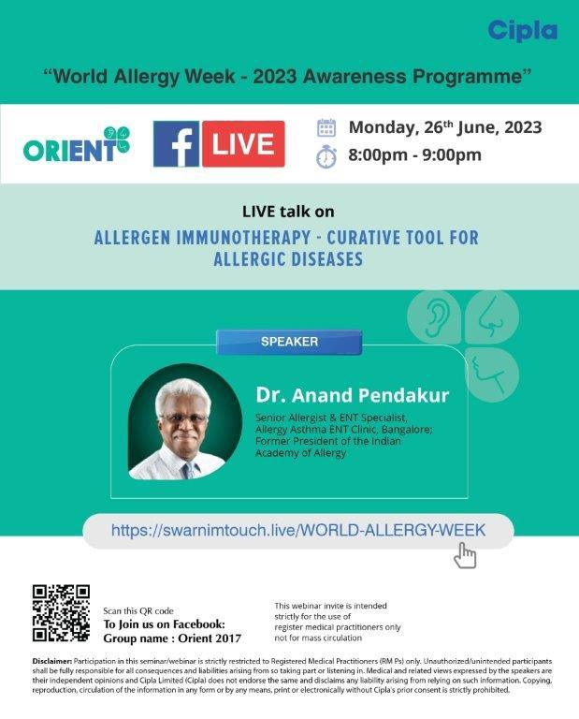

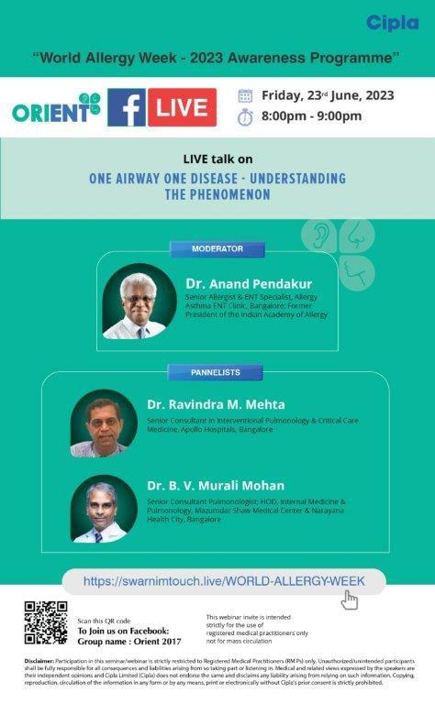
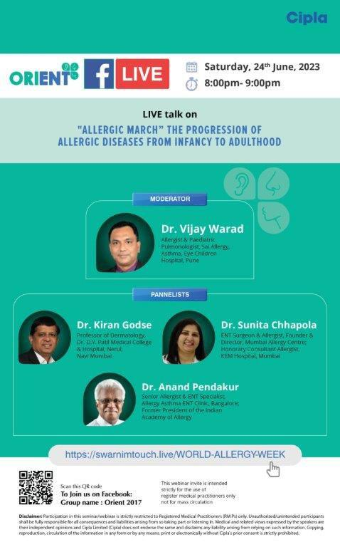

The faculties from the field of Allergy, ENT, Pulmonology, Pediatrics & Dermatology were involved in these series of webinar with below mentioned agenda:
Topic:Interactive Lecture on Art of Collecting History: The Driving Force for the Diagnosis of Allergy.
Date & Time: 22nd June 2023 from 7-8 pm.
Speaker: Dr Anand Pendakur
Key Highlights:
History is a companion for allergy diagnosis.
Allergy mostly manifests in skin, mucous membrane of the respiratory tract and GI tract.
Leading questions, talk-time to the patients, associated symptoms with allergy, etc are important factors to note for diagnosis of allergy.
History of parents with allergy increases the chances of children to acquire allergy.
Environmental factors, occupation, animal contact, etc are few important factors in history of diagnosis for allergy.
Topic: Panel Discussion on One Airway One Disease – Understanding the Phenomenon.
Date & Time: 23rd June 2023 from 8-9 pm.
Speakers: Moderator – Dr Anand Pendakur
Panelists – Dr Ravindra M Mehta&Dr B V Murali Mohan
Key Highlights:
About 99% of patients with allergic asthma have allergic rhinitis and about 1/3rd of the AR patients develops allergic asthma.
Control of both the conditions is equally important for adequate prognosis.
Early allergy treatment would prevent the increasing prevalence of comorbid allergic conditions.
AR also has systemic effects like fatigue, neuropsychiatric disturbance, etc.
Viral infections are usually involved in triggering AR and Asthma.
Intranasal surgeries lead to loss of protective factors for lower airway and may trigger pre-existing asthma.
Immunotherapy is the only cure to allergy.
“Attention to both and focus on One” should be the treatment modality for United Airway condition.

Topic: Panel Discussion on Allergic March – The Progression of Allergic Diseases from Infancy to Adulthood.
Date & Time: 24th June 2023 from 8-9 pm
Speakers: Moderator – Dr Vijay Warad
Panellists – Dr Kiran Godse, Dr Sunita Chhapola Shukla & Dr Anand Pendakur.
Key Highlights

Prevalence of Allergy in India is about 25-40%. Post COVID there has been rise in allergies across all age groups with more Th2 response.
Early recognition of allergic symptoms (Eczema, Atopic dermatitis) in children and treatment may prevent allergic march. ‘Steroid myths’ should be tackled for the patients.
Switching to western food is one of the factors for increasing prevalence of food allergy.
5-10% of AR patients may have otitis media as a comorbidity.
Prevention of allergy in children starts from the time they are in the womb.
Playing out, sound sleep and few ordinary things in childhood are important to prevent allergic march. Immunotherapy in early age could help the child live a healthy life and socialize.
Topic: Interactive Lecture on Allergen Immunotherapy – Curative Tool for Allergic Diseases.
Date & Time: 26th June 2023 from 8-9 pm.
Speaker: Dr Anand Pendakur
Key Highlights
There is no age limit for SPT; however, in our country it is done in patients above 4-5 years.
Single allergen or mono-allergen treatment is preferred and recommended.
SLIT seems to be safe and compliant immunotherapy compared to SCIT.
Informed consent, counselling, demonstration on method of use, possible reactions and precautions, etc., should be discussed with the patients placed on SLIT.
SLIT patient dropout percentage is less compared to SCIT.
Adrenaline should be available with the patients on Subcutaneous immunotherapy in order to be used in case of any untoward reactions and anaphylaxis.

Audience:
Specialist Doctors from ENT, Pulmonology, Internal medicine, Dermatology and Pediatrics registered and were present during the webinar.
There were ~11,000 doctor registrations done for these series of webinars PAN India and Avg ~400 live audience were present for each webinar.
All these webinars are uploaded on various digital platforms of Cipla for the HCPs from ENT, Pediatrics, Chest physician and Consulting physician to go through anytime.
Audience Questions:
Below are few of the audience questions during the session:
Roasted peanut or boiled peanut? Which one is more allergic?
Why are Hyperthyroidism patients prone to be infected with allergic Pharyngitis and Laryngitis.? Is there any physio- pathological coordination between these hormonal and pathological disease?
Sometimes Urticaria is not reduced by using Antihistamineslike Avil, cetirizine, fexofenadine, Bilastine etc. Then what? Dr Rajendraprasad Bansilal Gilda.
Fungus is mostly getting resistant to medicine? Please comment.
After wake, when patients touch the water and wash their face, they experience Regularly sneeze in the morning more than 7,10 times. Please doctor suggest something about it what to do because I saw couple of patients like this?
Does early introduction of small amounts of wheat / bovine milk, before 6 months of age prevent allergy to these substances?
What’s the role of Immunotherapy in preventing Allergic March?
Is there any high-level evidence about Infantile or Toddler AD age group immunotherapy to prevent further progression of Allergic March?
I have diagnosed many pts with OSA proven on Sleep PSG studies, with Clinical History & exam associated with AR with Sinusitis with Adenoidal & Tonsillar Hypertrophy? Please comment.
Recording links for all the 4 webinars:
This is the recording link for Cipla - World Allergy Week - 22 June

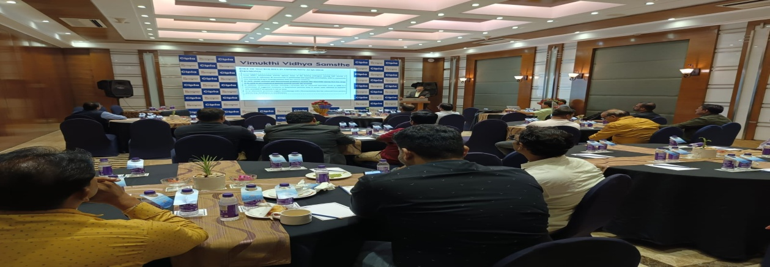
https://drive.google.com/drive/folders/1T0FteqryQ3kgokXgnE-aVH2-AHBtvLlq?usp=sharing
This is the recording link for Cipla - World Allergy Week - 23 June
https://drive.google.com/drive/folders/1m3jyHRO4KCtzuy_pRL1oeX-Ptknw-7YY?usp=sharing
This is the recording link for Cipla - World Allergy Week - 24 June
https://drive.google.com/drive/folders/1XPU9f_5-IfAcWTKCoQx-1ywxGCnld8BJ?usp=sharing
This is the recording link for Cipla - Orient - World Allergy Week - 26 June
https://drive.google.com/drive/folders/1B8M6zf_8eEO9MMs-5yktp_SVcvRw3x29?usp=sharing

Vimukthi Vidya Samsthe-Chitradurga
Activity report for the period April 2023 to March 2024
Supported by Open Hands India-UK
Part-A Growing, caring and protection of plants and kitchen garden | Activities carried out and photos
1. Orientation on the vision and mission of the Herbal and Kitchen garden to project staff and volunteers | On 9.6.2023 a one day orientation session was held for Vimukthi team, board members and Volunteers was conducted at Dhamma by the Director Vishwa Sagar on the vision- mission , activities of the Herbal and Kitchen garden supported by the Open Hands India-UK. Everybody appreciated and liked the uniqueness of the program and said that they will support and participate in the implementation of the project.  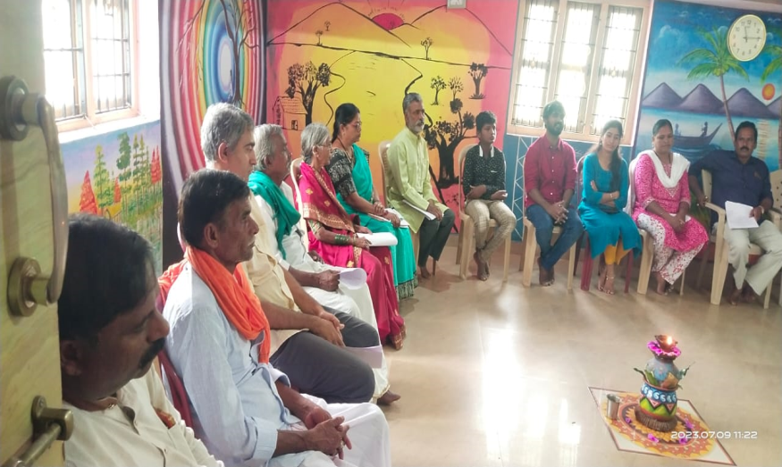  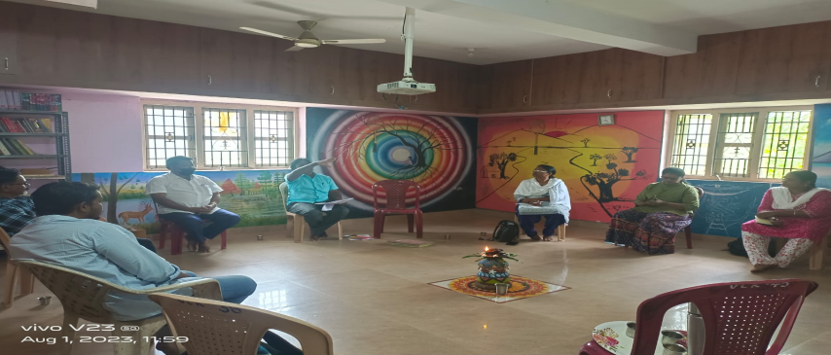
2. Orientation to School teachers, Students and members of SHGs on herbal and kitchen garden | In June and July Orientation to the school teachers and students and to the members of SHGs was carried out in selected schools and SHGs on the concept of kitchen garden, science in pots and my forest by the Vimukthi team and the volunteers.  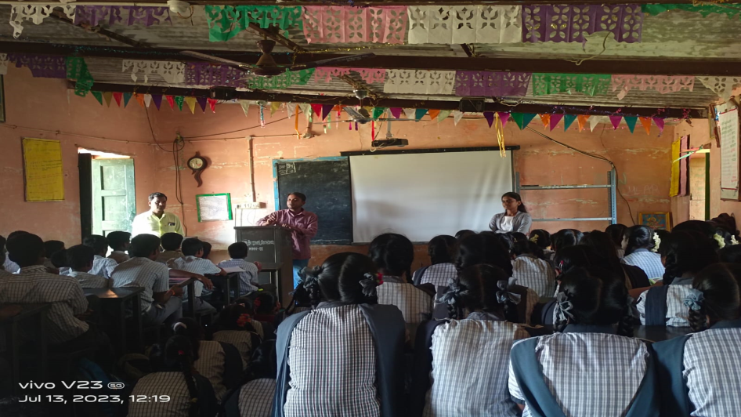
Above at Bhadra High school, MK Hatti by Aranya sagar and Arpitha
Below at Dhamma by Gururaj and Nagarathna
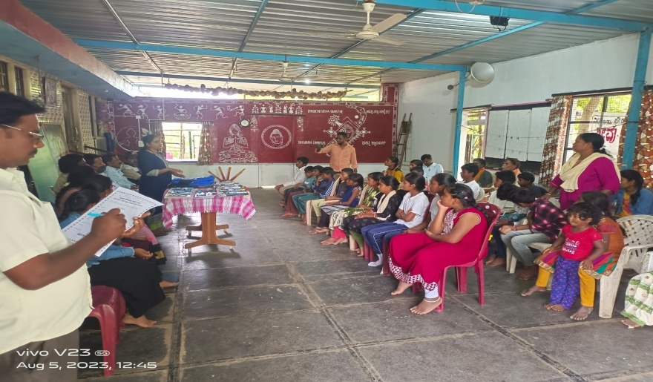
3. Purchase of Herbal and vegetable seeds, pots, compost fertilizer and other accessories to grow herbal plants on Dhamma la | In July month required quantity of pockets and sand was purchased and sand was filled by the project team and seeds were put in to the pockets. Further watering and caring was continued for 2 months. In addition to this about 750 different plants were purchased and mobilized on free of costs from private and government nurseries, particularly from the social forestry department  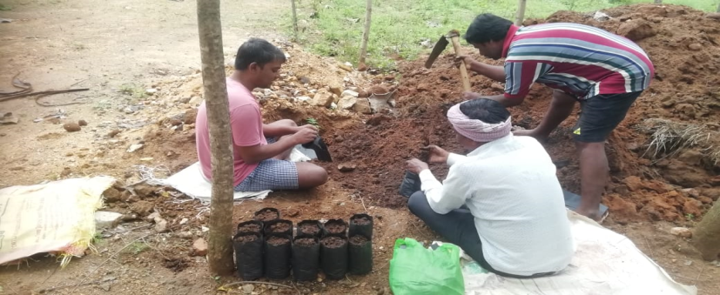
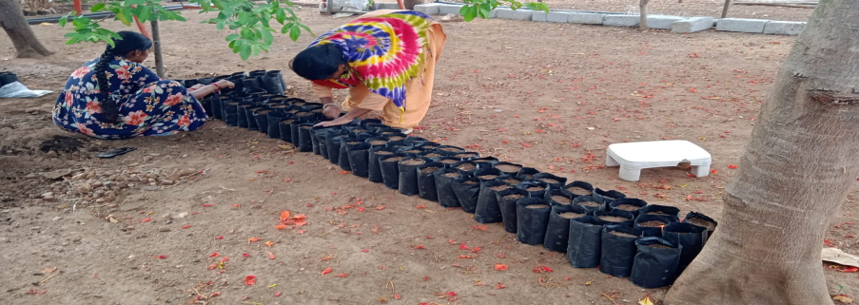

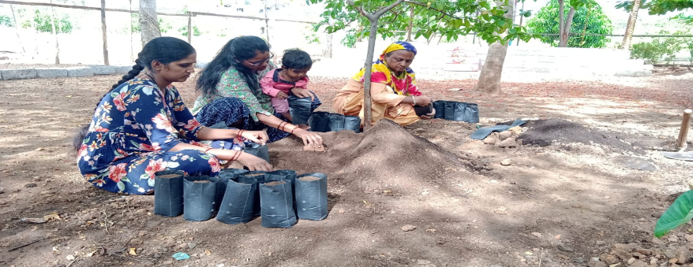

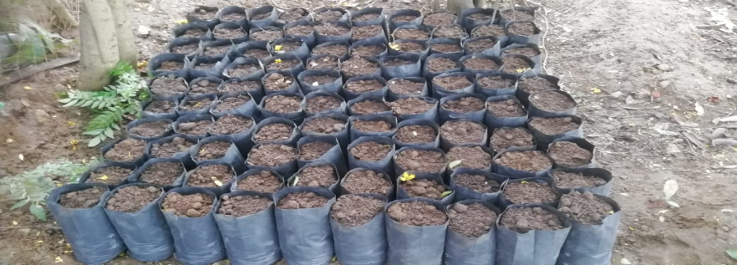

Below-purchase of plants from Nurseries
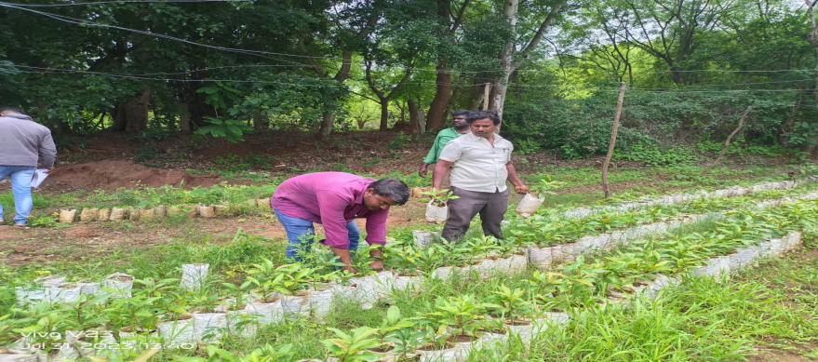

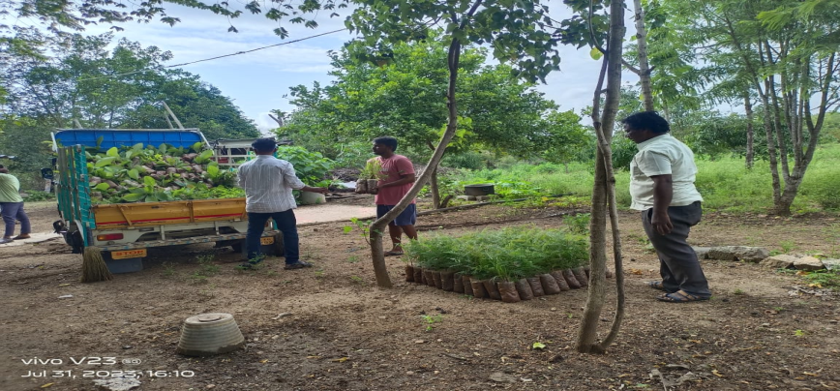
Unloading of Plants at Dhamma campus.

4. Exposure of Teachers and Students to Herbal garden- Dhamma | Schools were contacted by the field staff and volunteers and had dialogue with the teachers on environment project of Vimukthi and they were invited to visit Dhamma eco sanctuary, particularly the nursery created at Dhamma  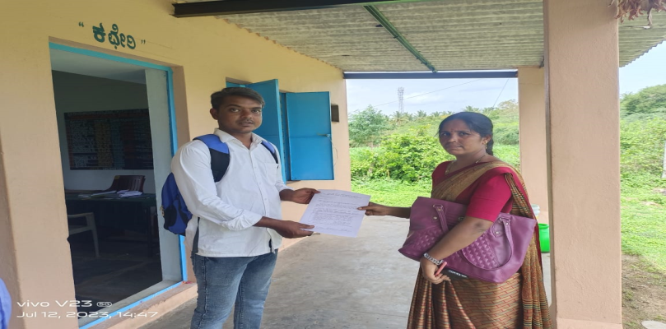  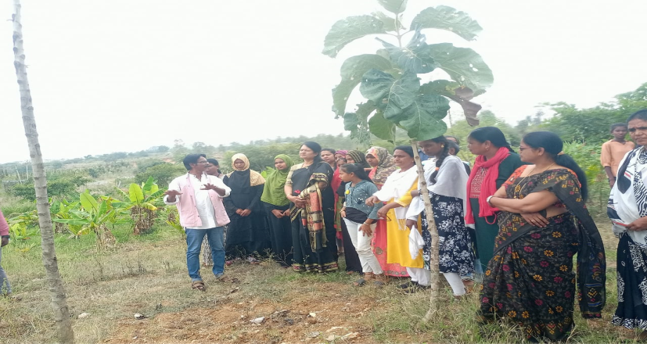  Teachers and members of Grama Panchayat and School development and monitoring committee (SDMC) visited the Dhamma eco sanctuary in two banc in first week of October 2023 and they were oriented on filed on the efforts of Vimukthi in creation of agri-forest and horticulture , using organic methods.  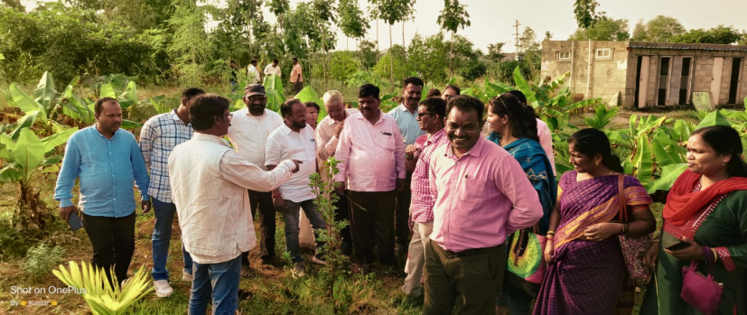
6. Celebration/inauguration with a festive environment in each school | After transport and distribution of plants at different schools the samplings were planted in a celebrative mood by the children, teachers and members of SDMC and Vimukthi team. Sapling were also planted at Dhamma land with the help of volunteers, neighboring chidlren and vimukthi team  Below at Dhamma-with the forest offcier  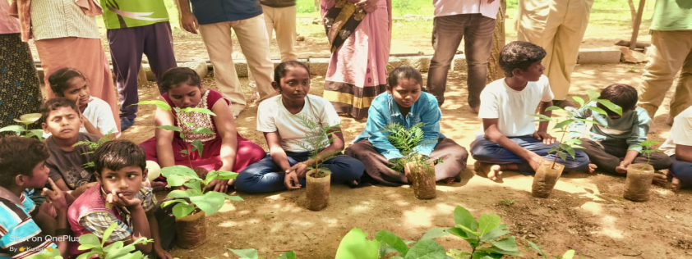  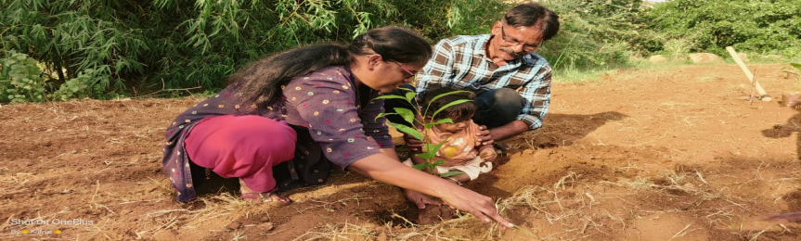  Above and below-Plantation work at Dhamma by team, volunteers and children  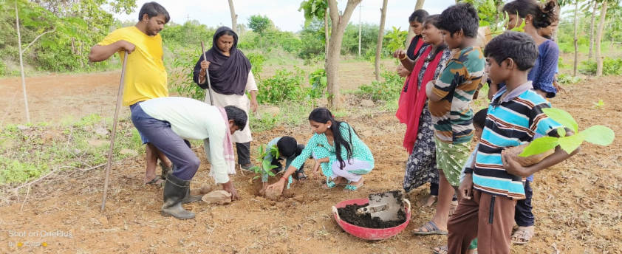  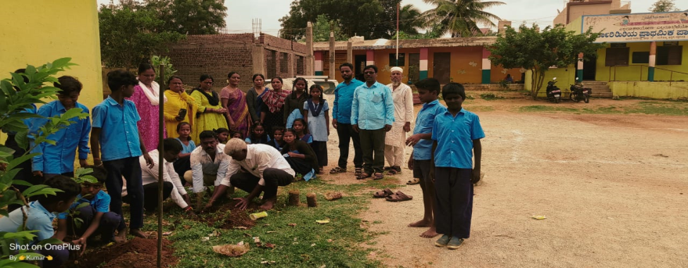  Above-At MR Nagara school , Nagarathna and Kumar T, Bibijan, Annapurna and school teachers  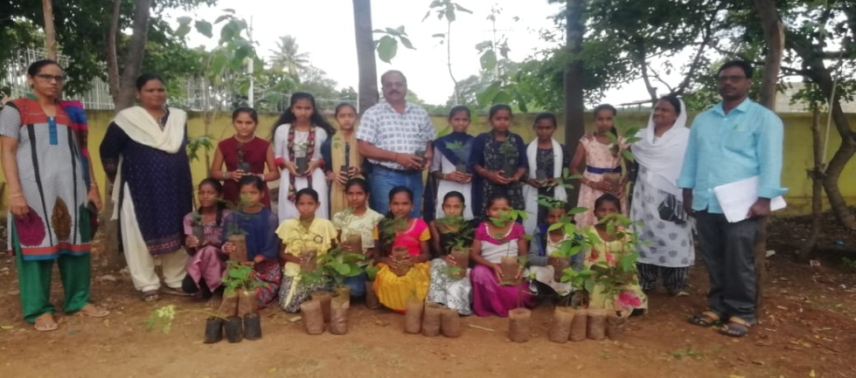  Above-GHPS-Inalli Kurubarahatti  Below- Government Hishg schoo-Inallai Kurubarahatti  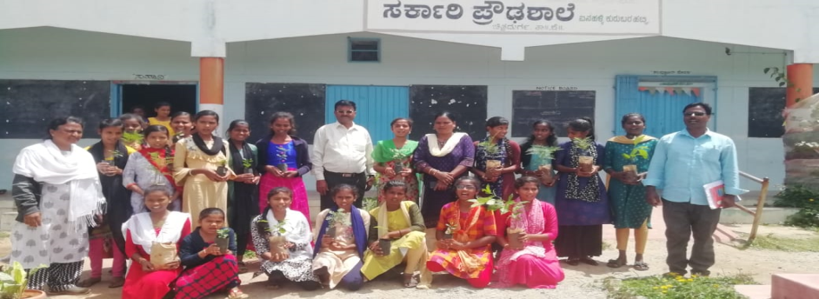  Below- Nethaji High school- Kyasapura  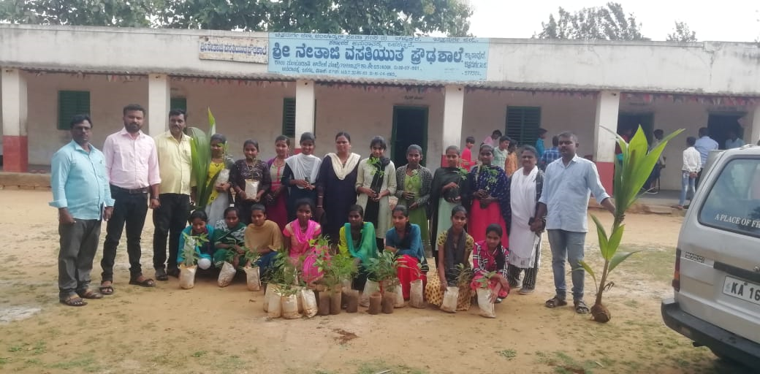  Below-Governmnent Higher primary school-Itol  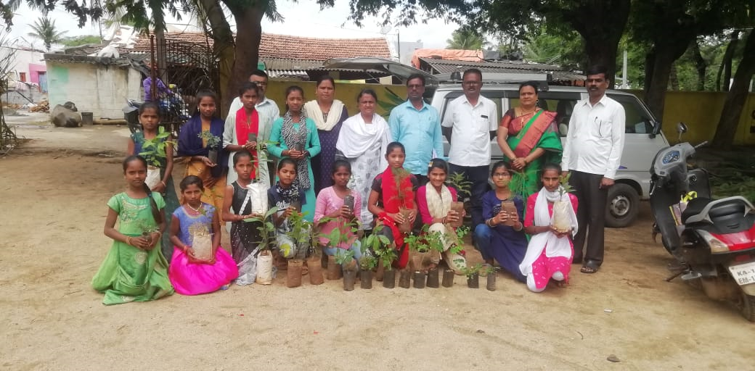
7. Organizing quarterly network meeting of the members of all 10 schools and 10 SHGs | 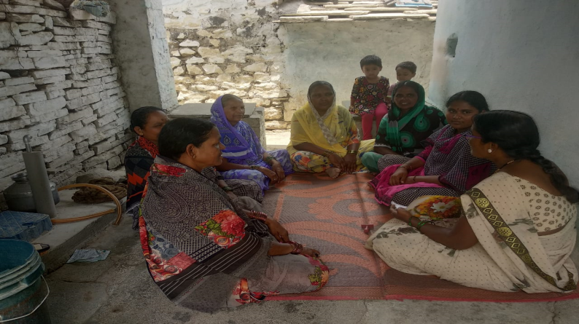
8. Awarding and rewarding with certificates and prizes to best 10 schools and 10 SHGs | An informal tests were conducted in selected 5 schools by way of drawing, speech competitions and they were honored with medals and certificates  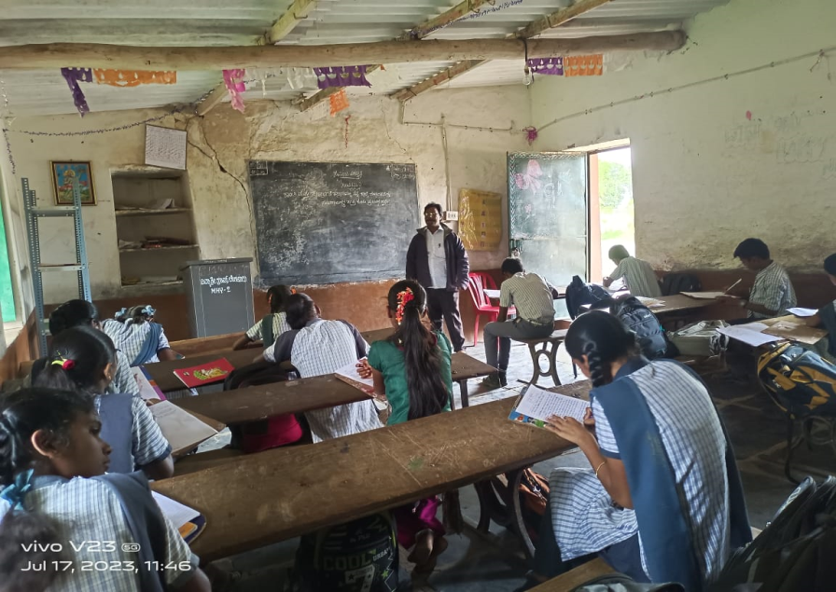  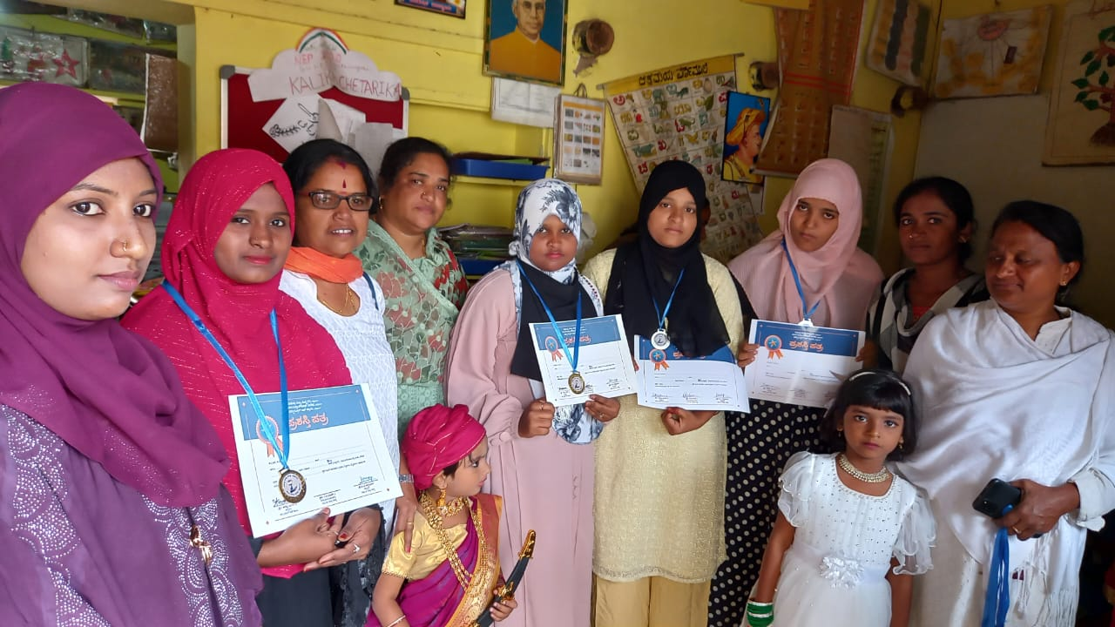  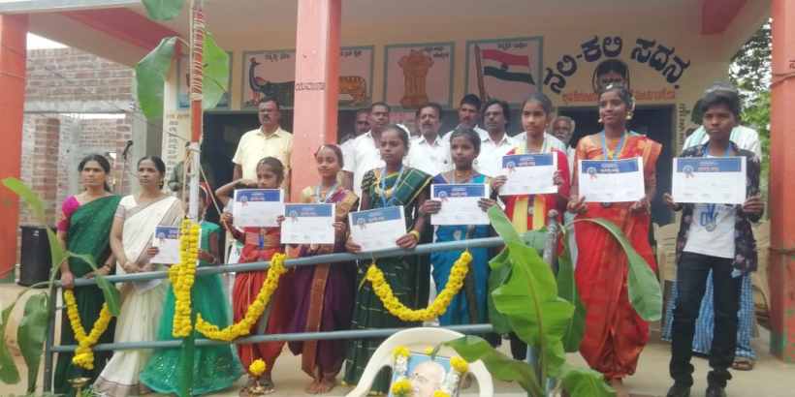
Part-B Health and Hygience
- Medical camps for Specially challenged | Medical camps were conducted at Sulepet in collaboration with health department for specially challenged by Surekha  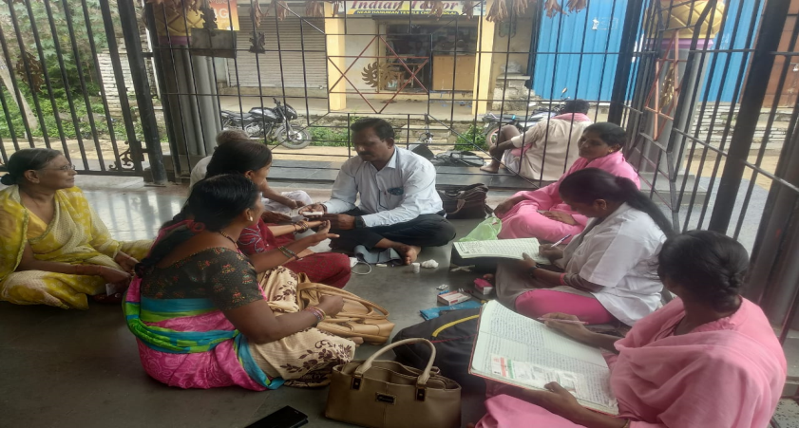
2. Training on Personal Hygiene for young girls | At school and Anganavadi level personal hygiene awareness for adolecent girls and women was carried out in April-May-June 2023 at Chincholi block by Surekha  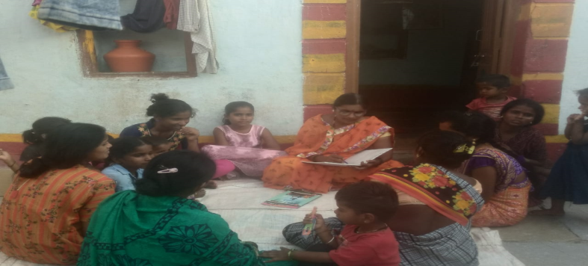  Above and below at Chincholi block  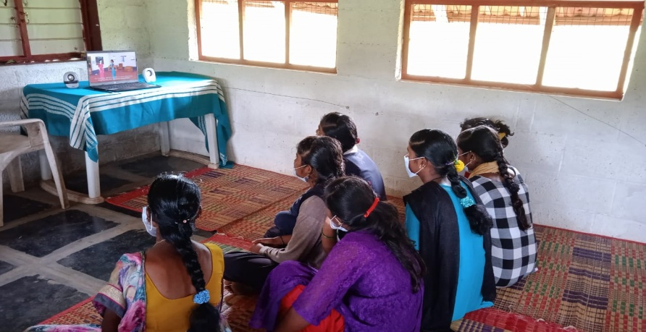  Below at Dhamma  A half a day orientation session was held on 12.8.2023 for Vimukthi team and volunteers on Personal hygiene by Dr. Girish the Taluk health officer, Dr. Reshma the Ayush department  On 28th and 29th October 2023 a two days training on Personal hygiene, career guidance, gender and eco system was conducted at Dhamma for 50 girls from 5 villages (10 girls from each village) . It was facilitated by Dr. Sunitha, Vishwa Sagar, Annaporna and Vimukthi team. Girls had a very meaningful input on the subject, made personal sharing, participated in creative exercises and games and enjoyed the songs, dance and games.  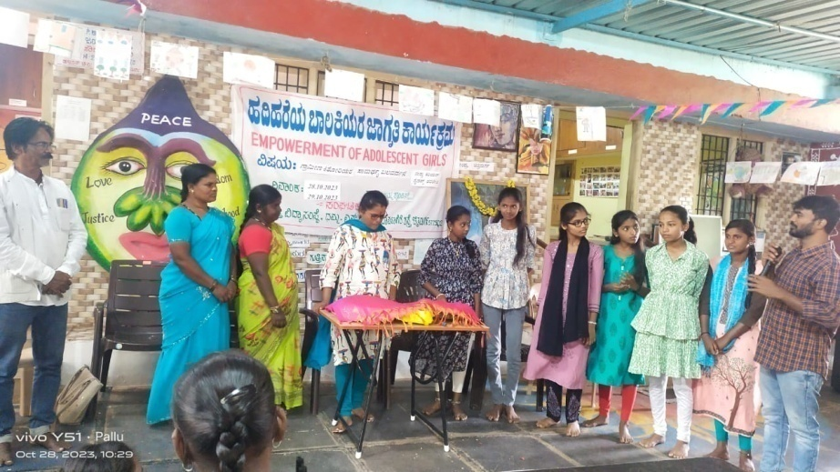  Two days training for adolescent girls at Dhamma  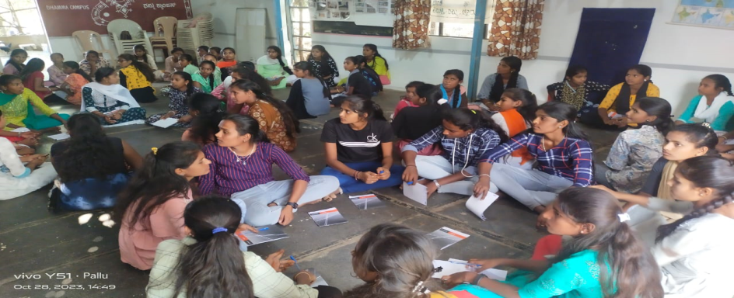  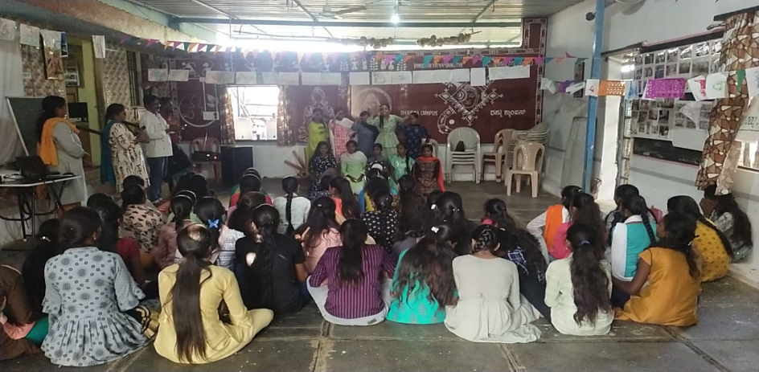
Part-C Promotion of organic farming
- Exposure and orientation on Organic farming | It is pending
- Cultivation of Millets on Dhamma land | Land was cultivated for sowing of millets in July 2023. But, due to lack of rain we could not take up further activities. This year, the entire Karnataka, including Chitradurga and Chincholi is experiencing drought like situation and it has become a hard and difficult time for farming community.  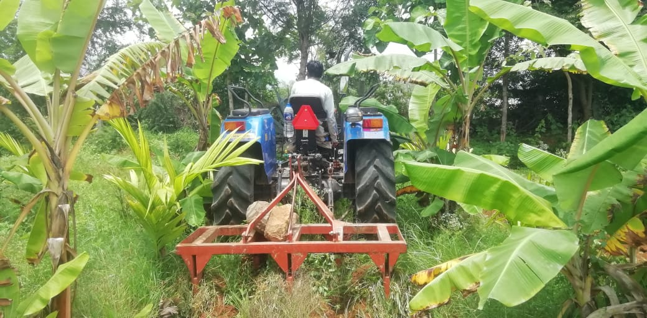  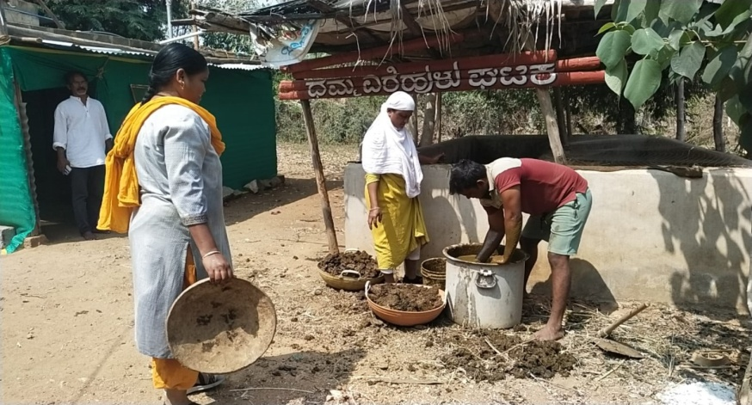  Preparing vermi- compost at Dhamma.
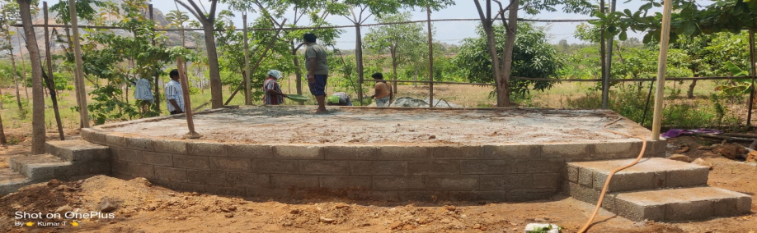

A stage has been created for cultural programs and major meetings/orientation, within the premises of Dhamma

A country cow and calf have been bought and they have been nurtured at Dhamma
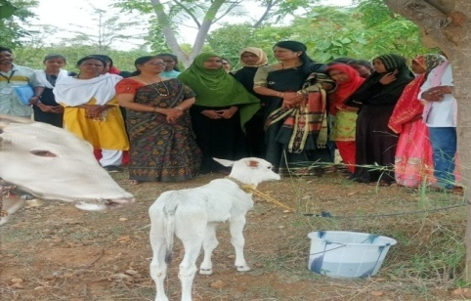

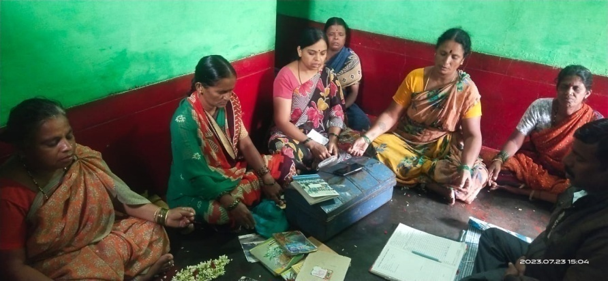

SHG meetings and training are continuing in both Chincoli and Chitradurga block

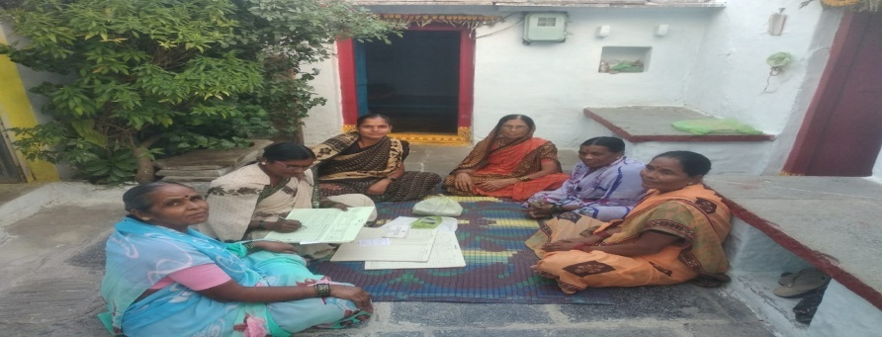

OHI- program 2

On 5.5.2023 a meeting of social and Religious leaders was organized at Dhamma in which Hindu Swamiji Basavanagideva, Muslim leader and retired DYSP Abdul Rehaman, District civil Judge Girish, Nomadic leaders, NGO leaders, children, officials, Vimukthi staff had gathered.

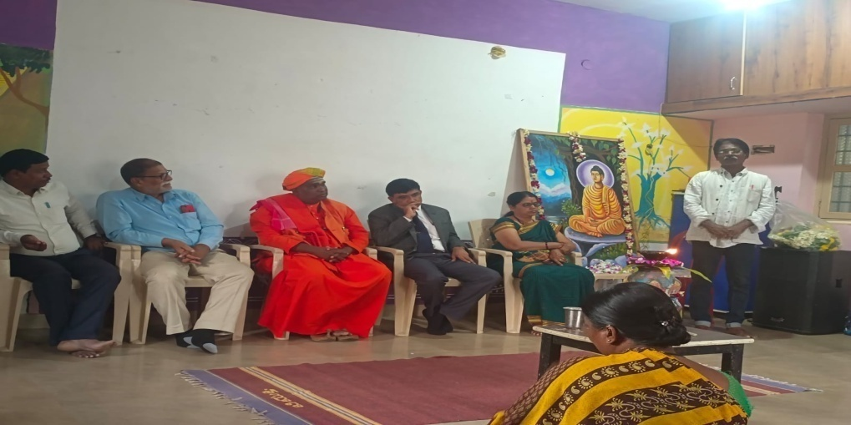

21.6.2023 on Yoga day Arpita at Medehalli and at MR Nagara school, Aranya attended the school program as resource persons from Vimukthi and they taught Theraputic yoga to children.

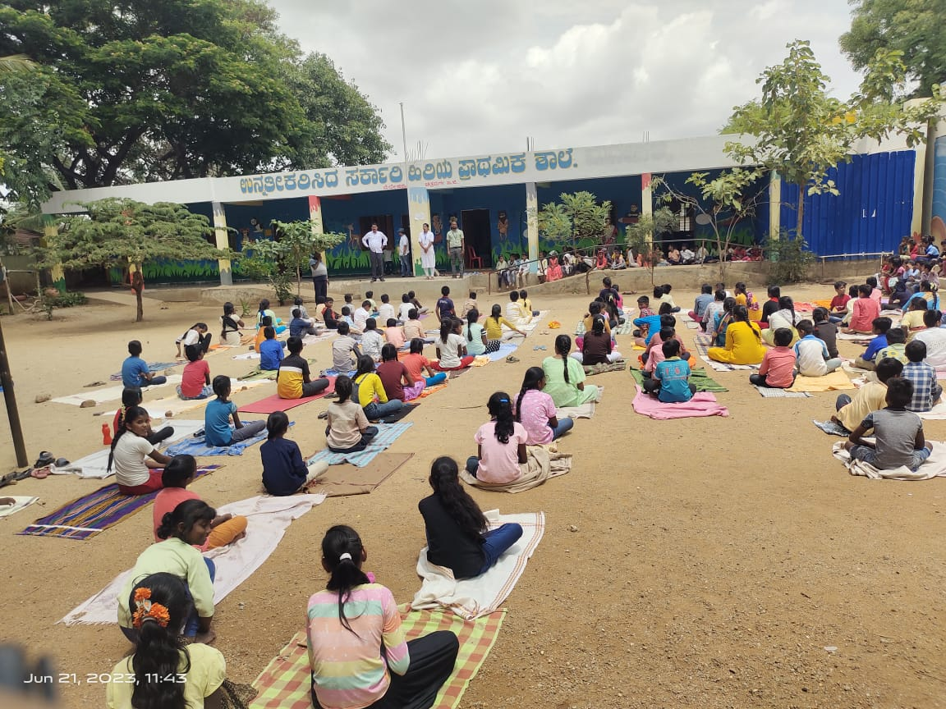

On 17.4.2023 Ambedkar Jayanthi and Iftar gatahering was celebrated at Tippu Shadi Mahal, Chitradurga 10highlighting the contribution of Ambedkar in creating Indian constitution and articles relating to religious practices, social justice and solidarity. It was attended by
Retired DYSP Abdul Rehaman
Paster Alexander
Islam religious leader Ahamad rabi
District peace committee leader Mr. Arun kumar
SHG federation leader Sushilamma
Students, Vimukthi staff, SHG representatives, NGOs and other social activists had gathered.

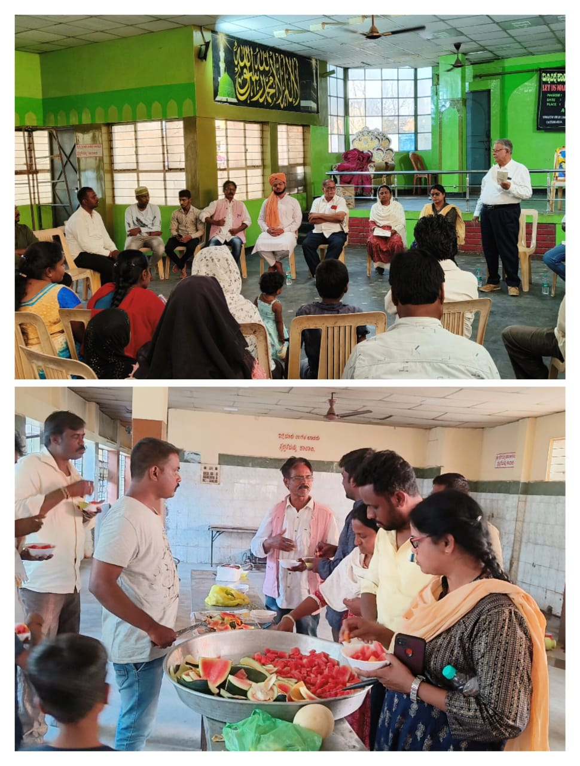

Celebration of Independence day at Dhamma on 15th August 2023. It was attended by Nomadic leaders, Muslim women and Vimukthi team.

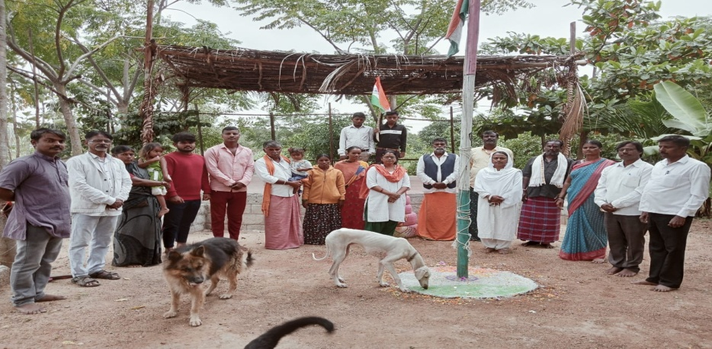

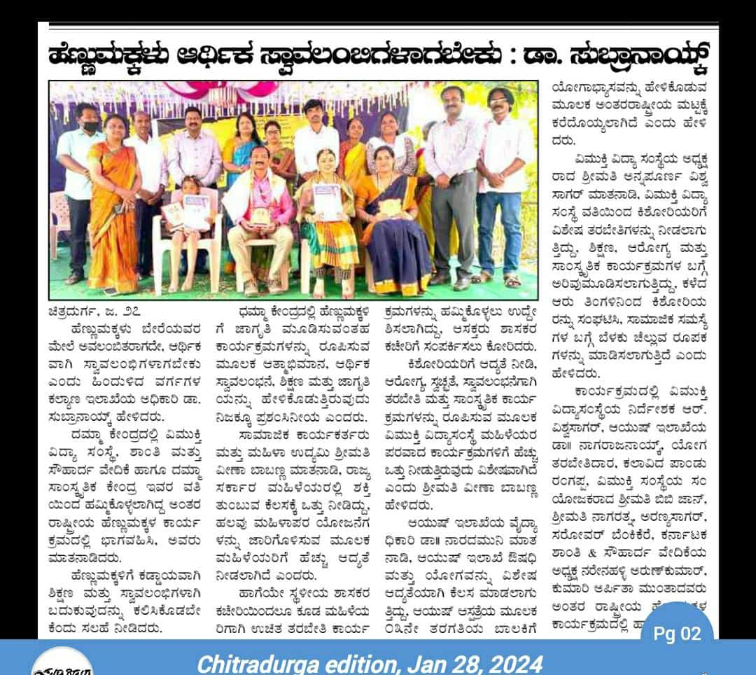

A one day training to identified Volunteers (youth from Colleges, villages and social activists) was held at Dhamma on need of volunteering for social and cultural cause and their engagement in national building. The sessions were conducted by Vishwa Sagar.R

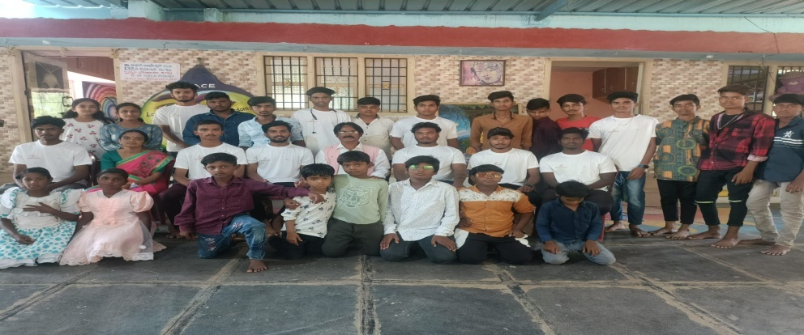

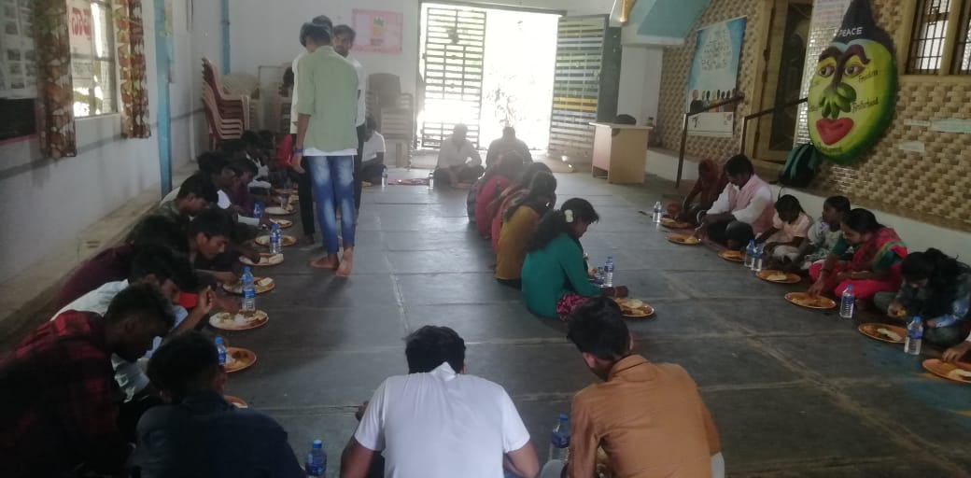

On 3rd November 2023 a one day media workshop was held
At Dhamma to educate media persons to cover more on issues of farmers, children, ecology.

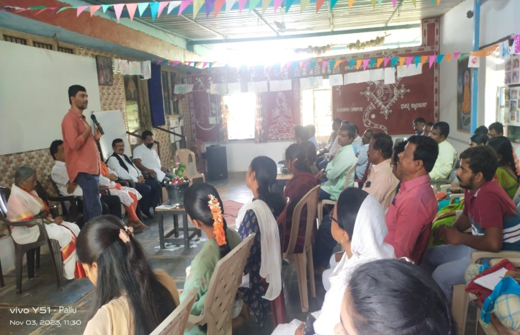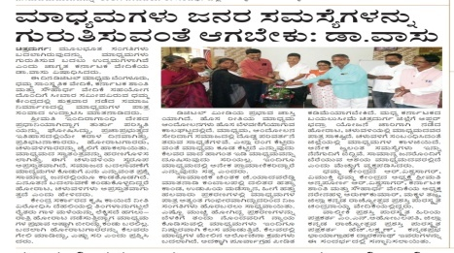

On 12.08.2023 a one day orientations for religious leaders and community leaders on social issues and role of public at Sevadal office, Chitradurga. It was attended by 3 Hindhu swamiji, 2 Christian leaders, 4 Muslim leaders, media persons, including CS Dwaralkanath, the Ex-president of state Backward caste committees.
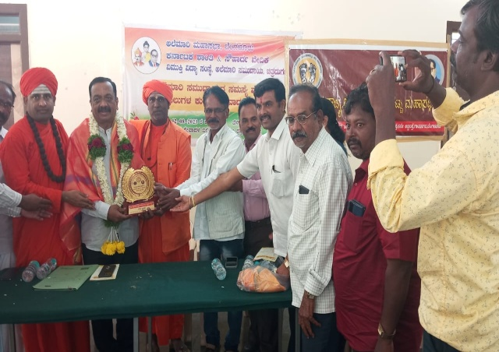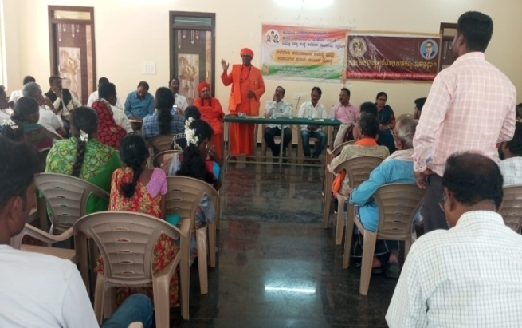

We extend our sincere thanks to Visthar, CIPLA, OHI for their financial contribution and our Board members, staff, volunteers for their sincere involvement in successful implementation of the project activities.

Vishwa Sagar.R
Project Director

